AWS Assignement Proof of Creation Document

Cloudformation stack - proof of automation

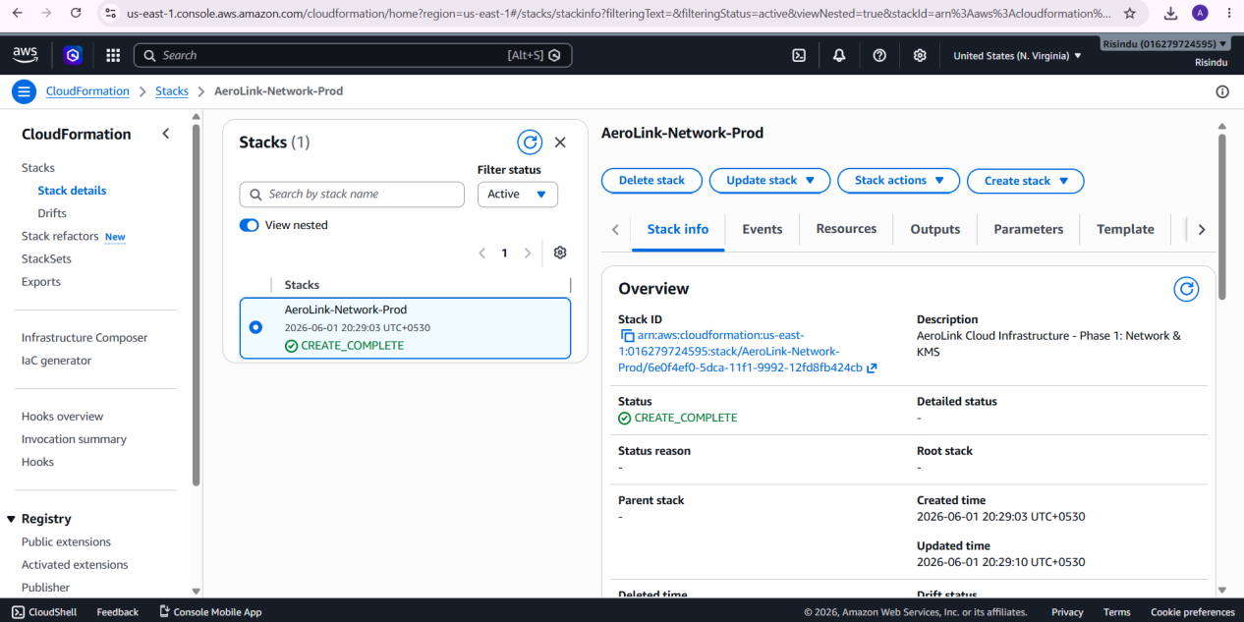
Image 1

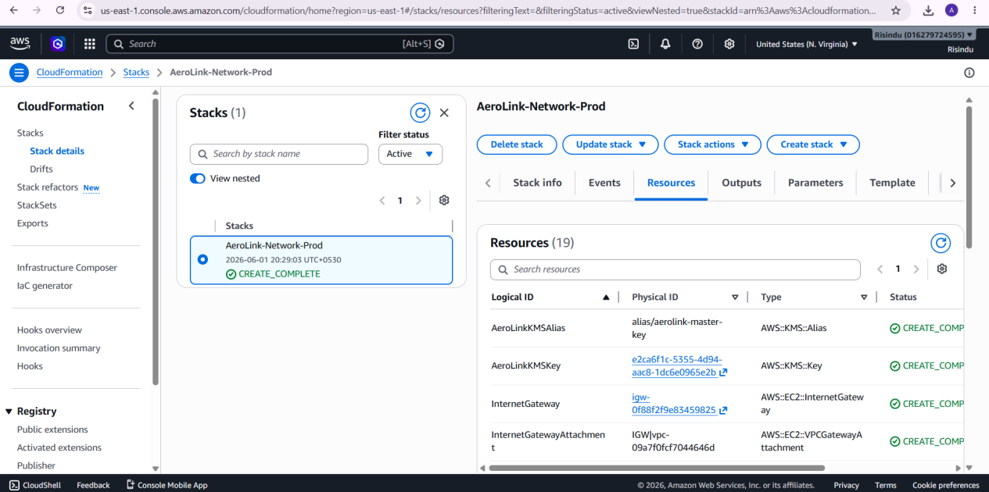
Image 2

VPC
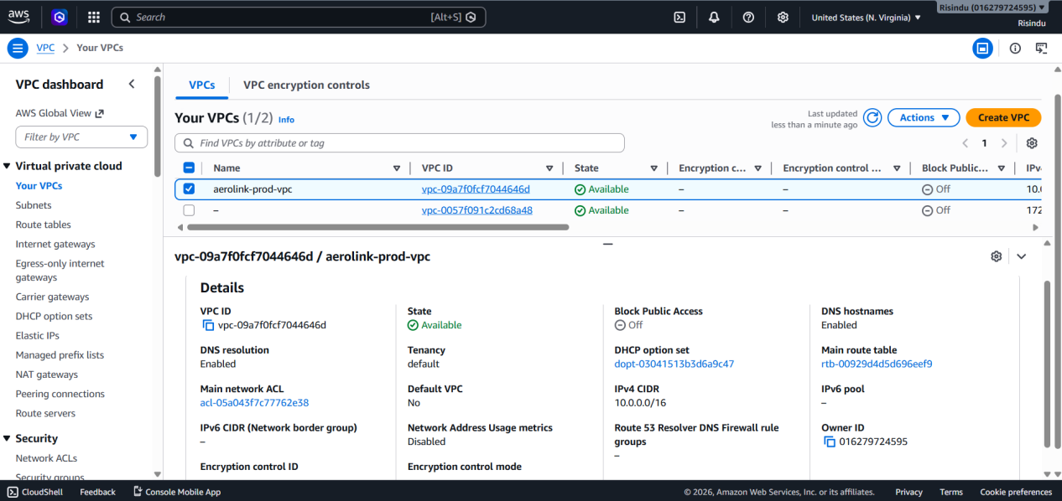
Image 3

Subnets (4 subnets are present)
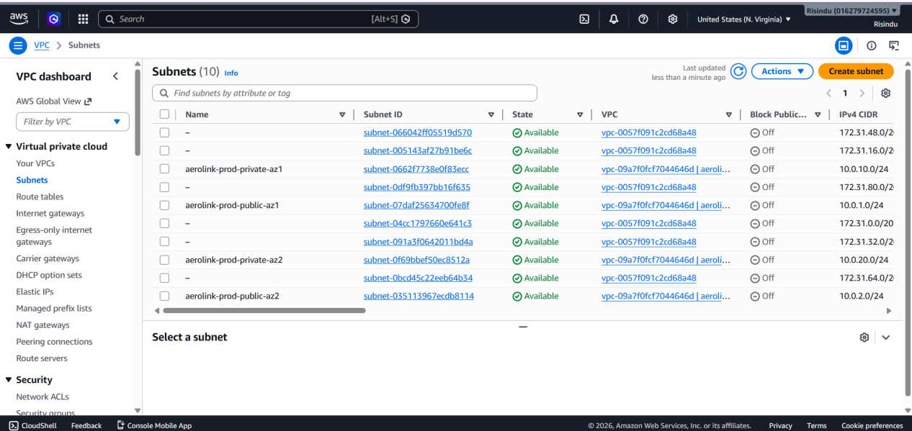
Image 4

NAT gateway

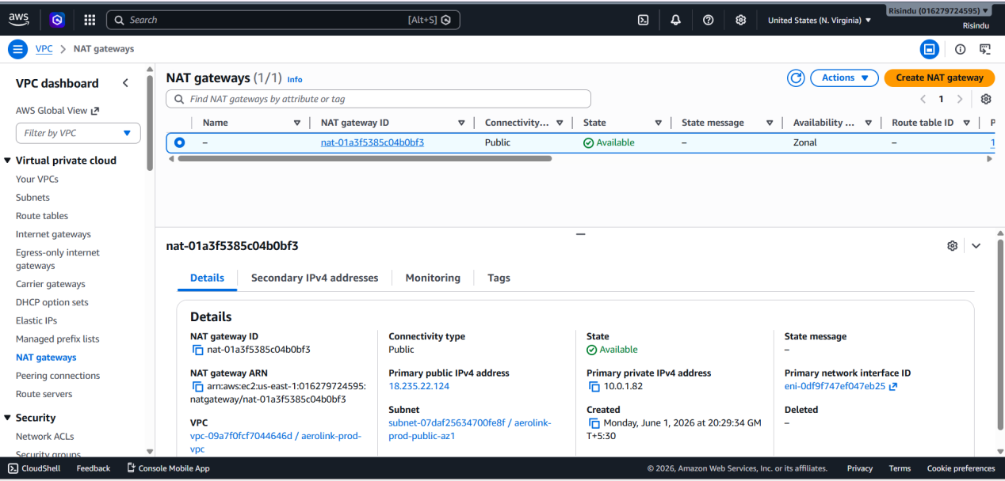
Image 5

Internet Gateways

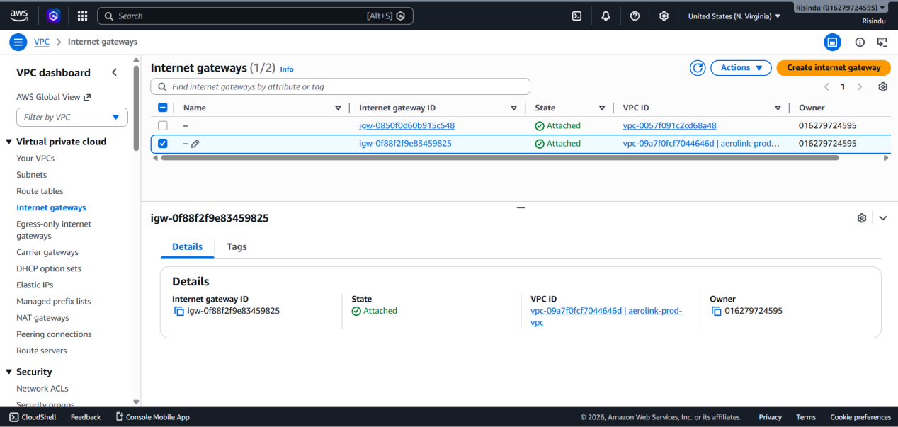
Image 6

Route Table
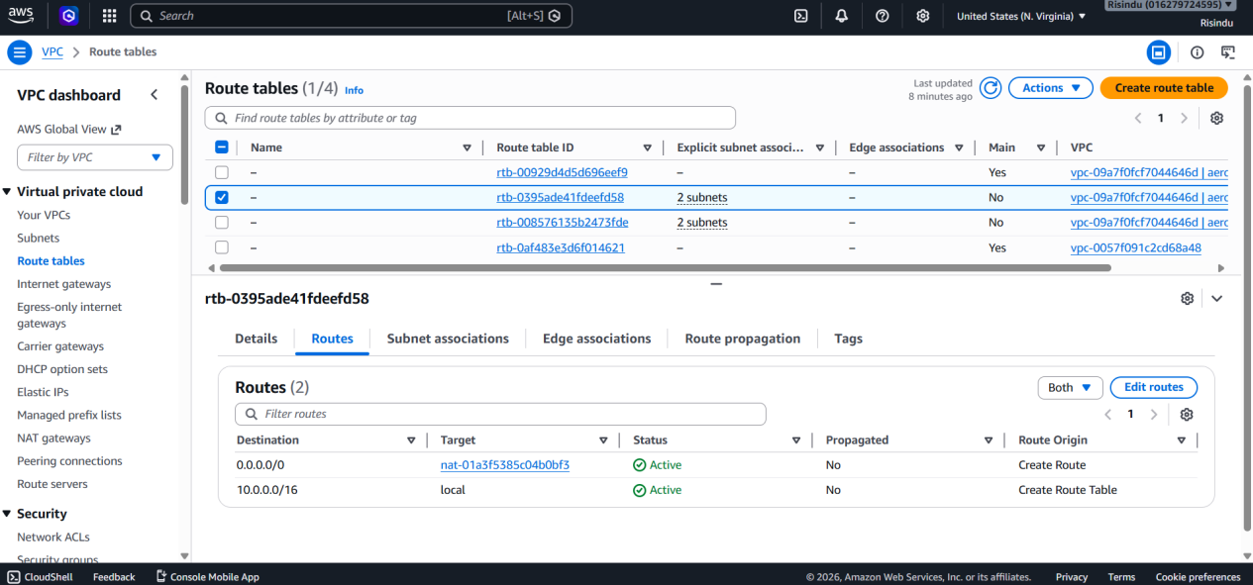
Image 7

Amazon KMS

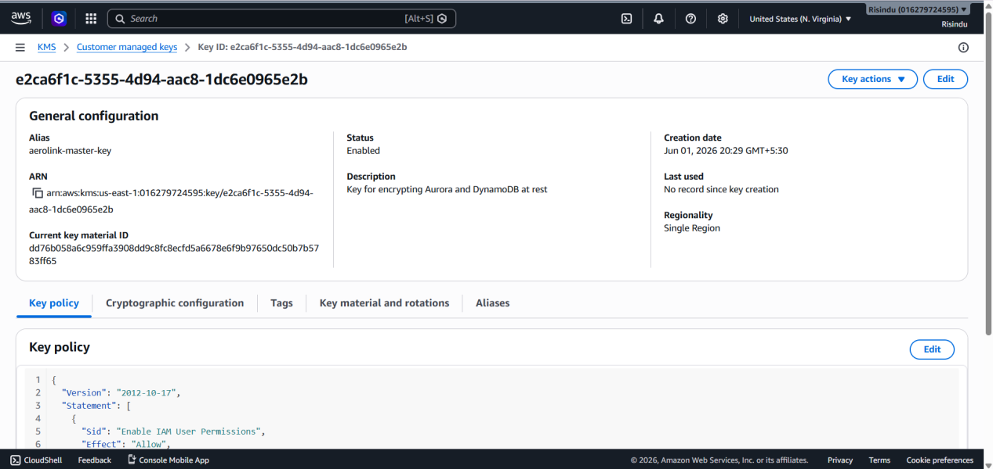
Image 8

Phase 2
DBMasterPassword=SuperSecretPassword123!

Cloudformation databases

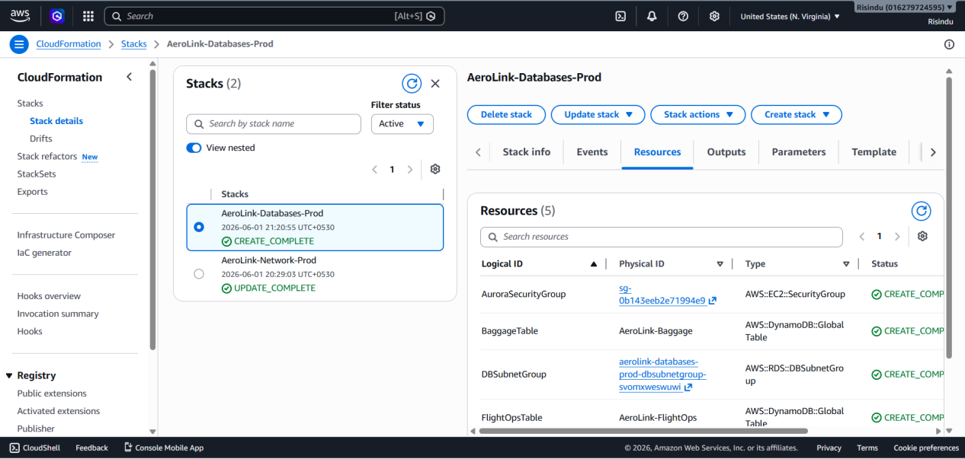
Image 9

DynamoDB multigion

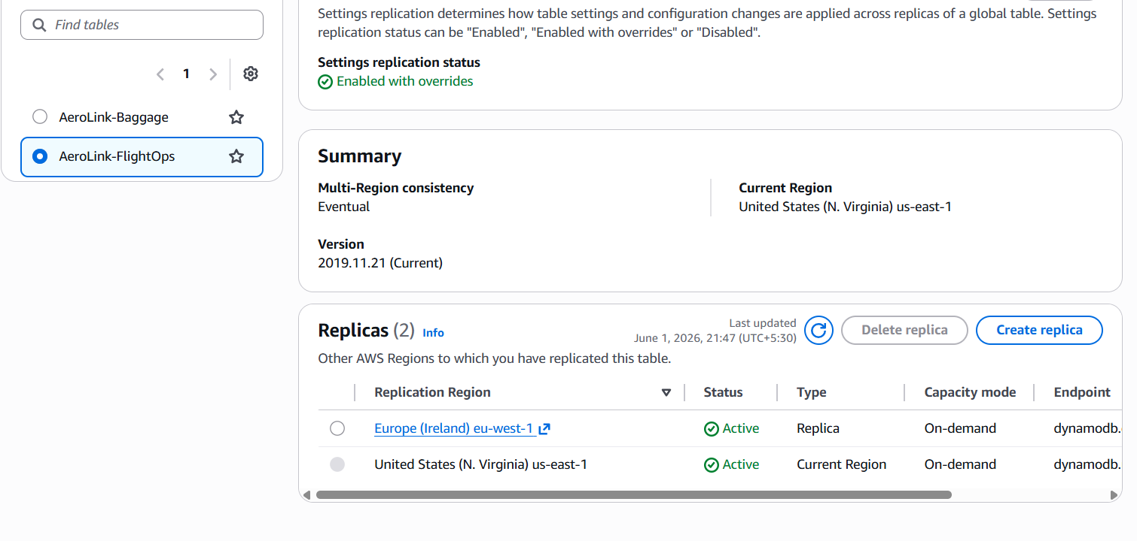
Image 10

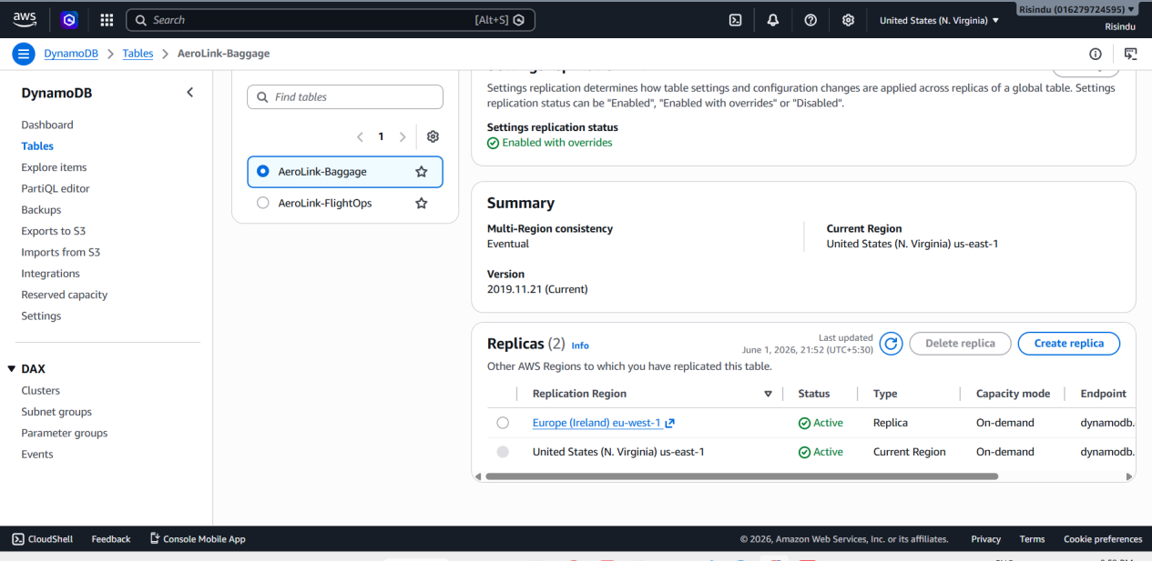
Image 11

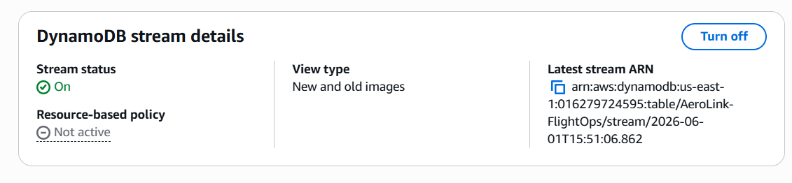
Image 12

RDS

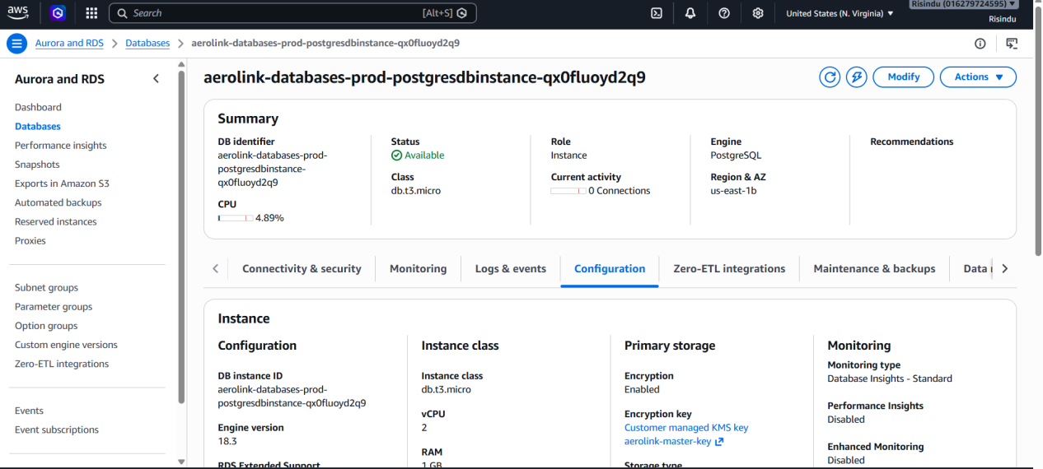
Image 13

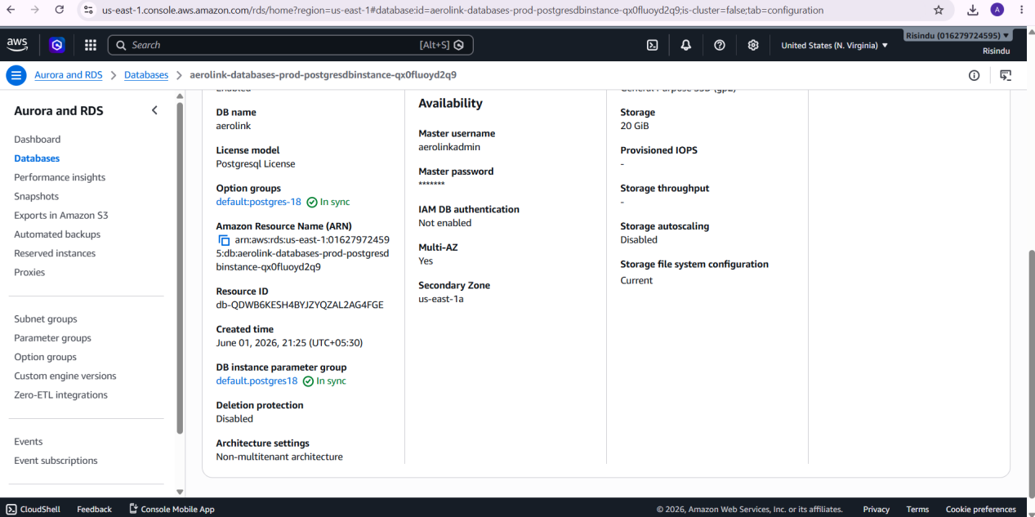
Image 14

VPC security groups

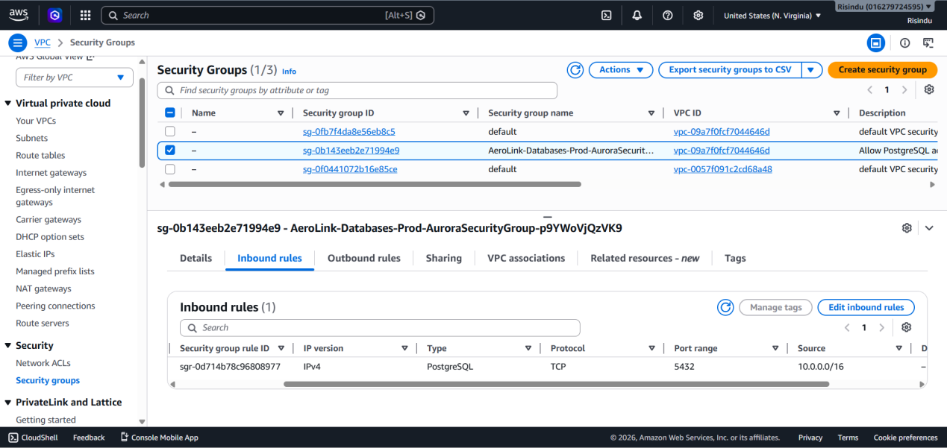
Image 15

Phase 3
Cloudformation

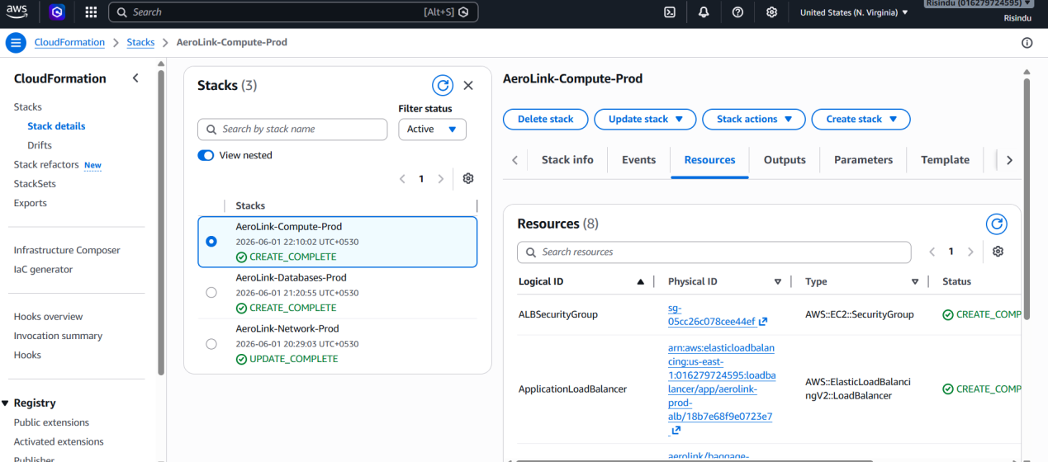
Image 16

Amazon ECR

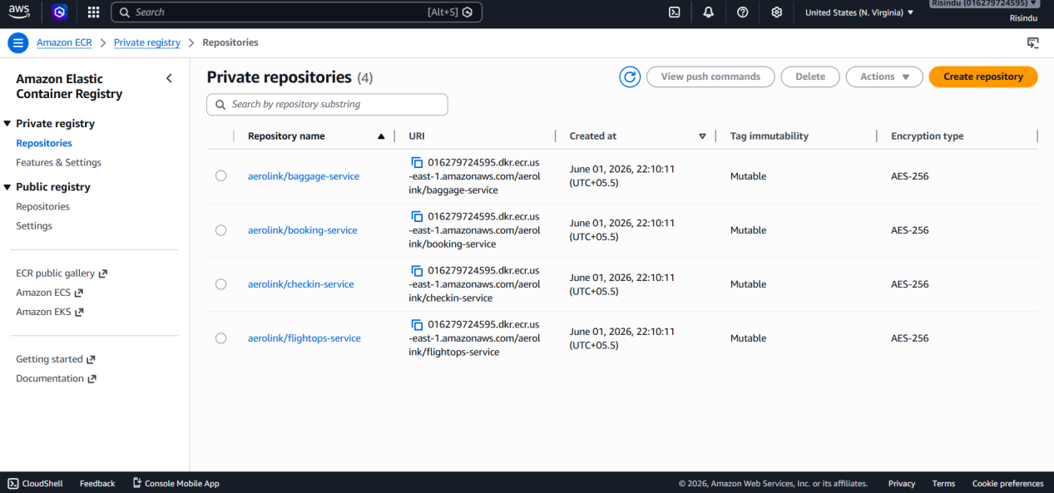
Image 17

Amazon ECS

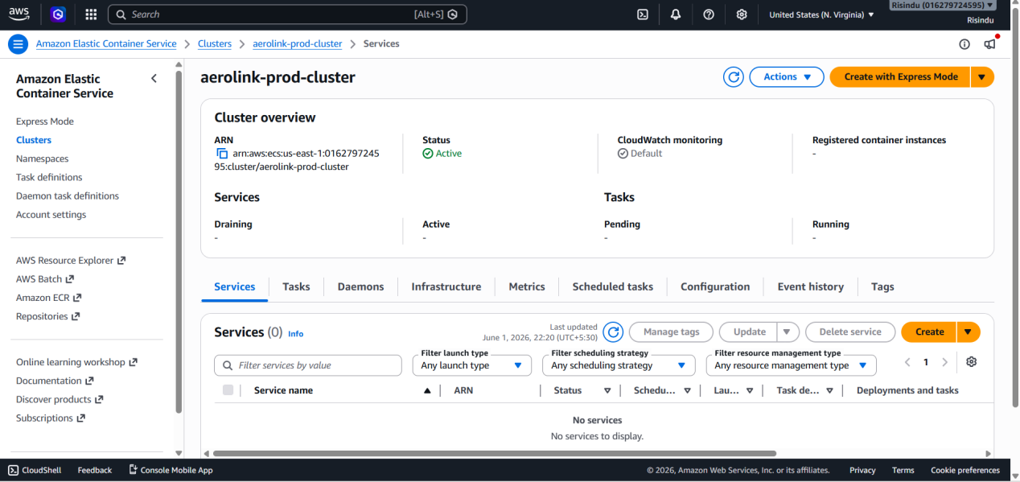
Image 18
load balancer

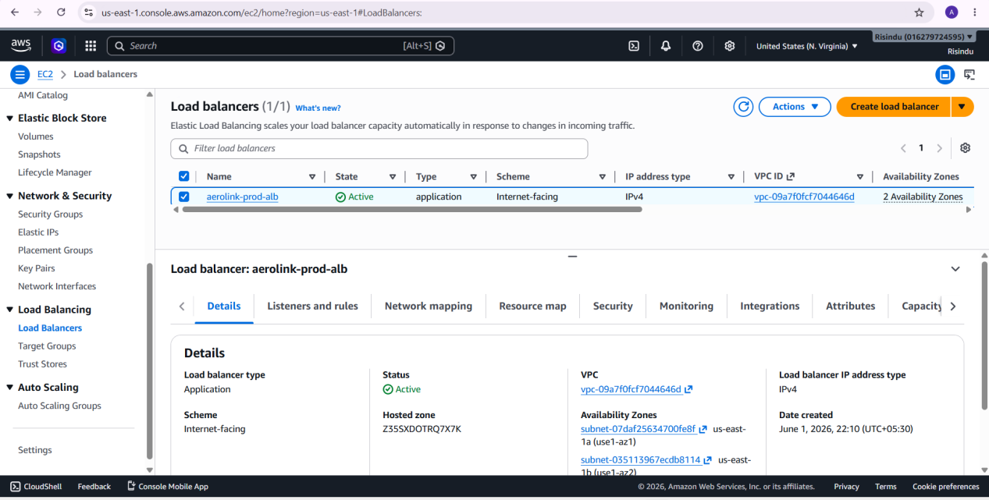
Image 19

Phase 4

Cloudformation
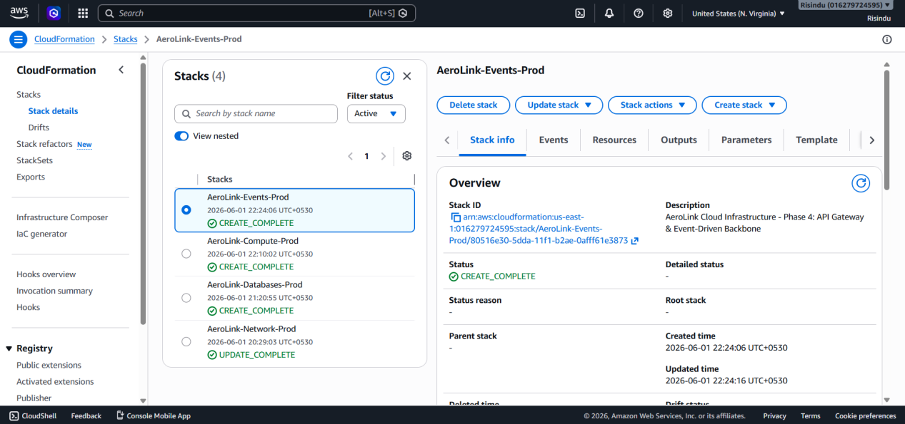
Image 20

API

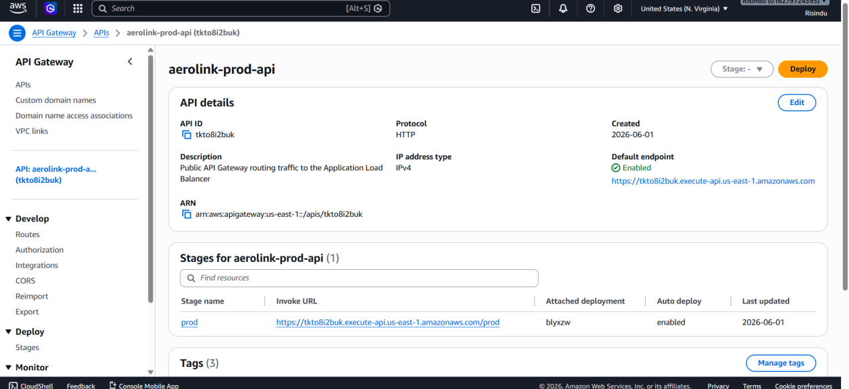
Image 21
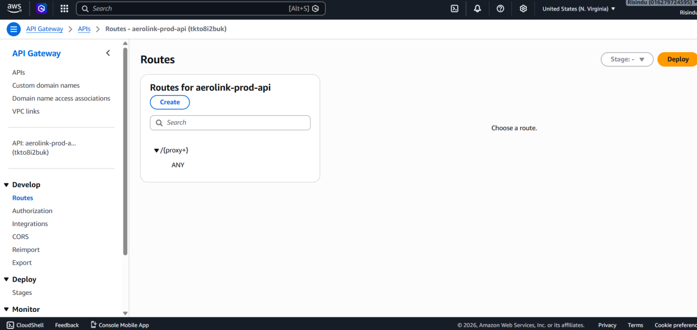
Image 22

Amazon cognito

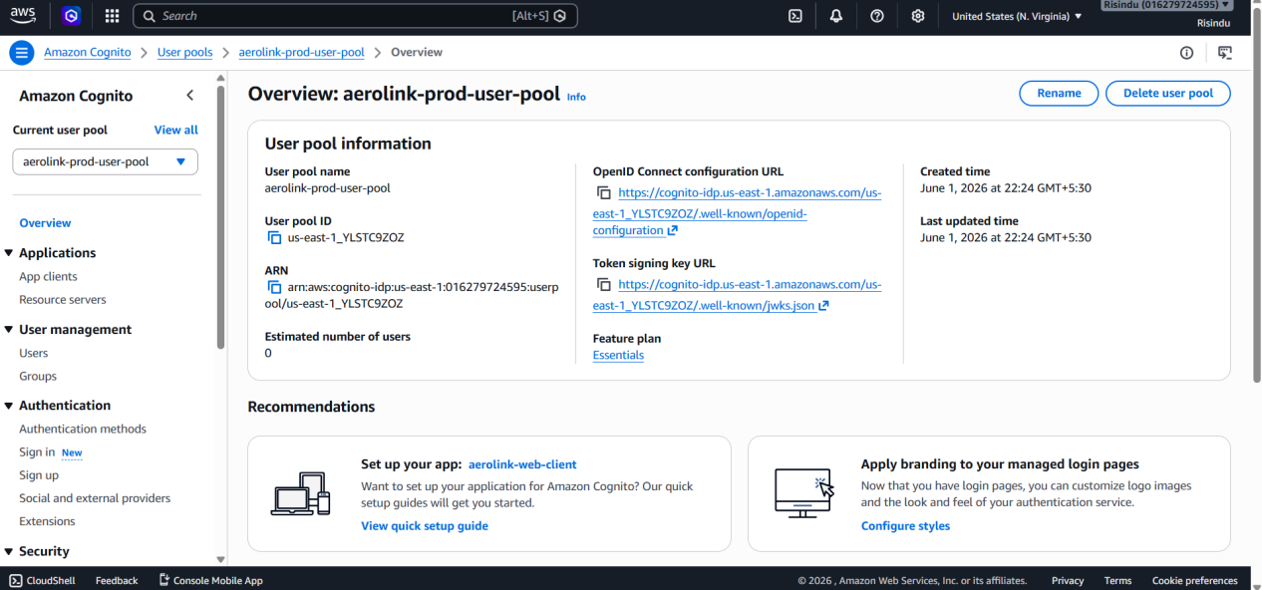
Image 23

Event bridge

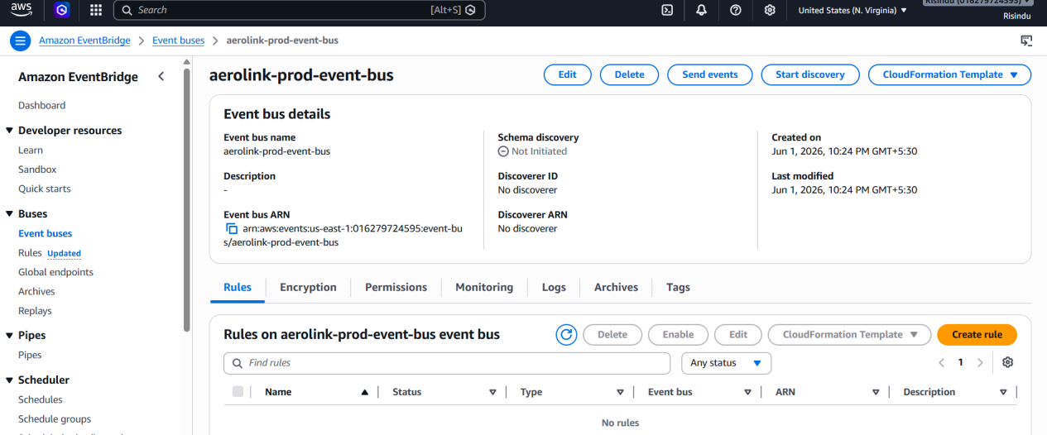
Image 24

SQS

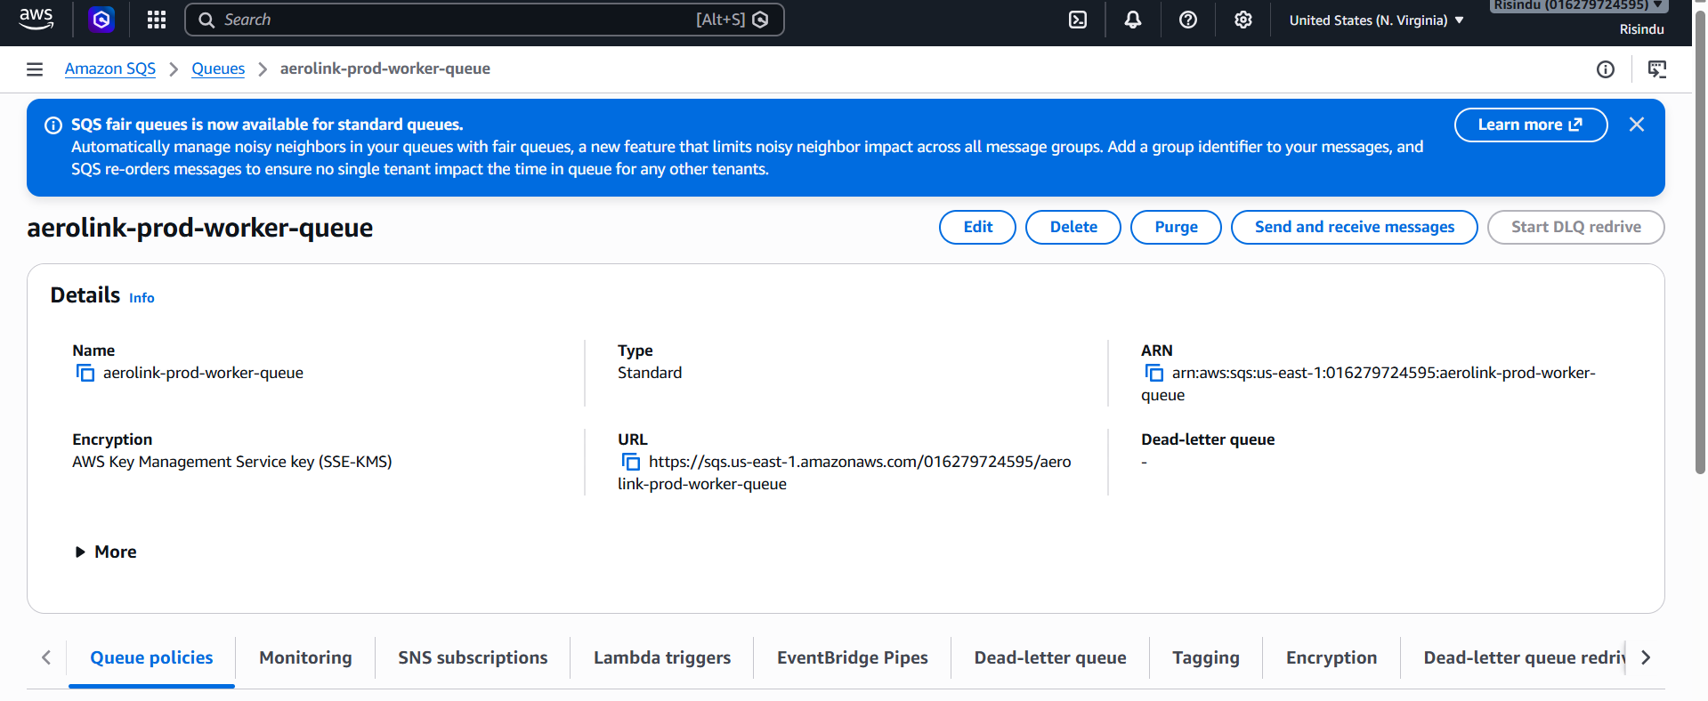
Image 25

Sns

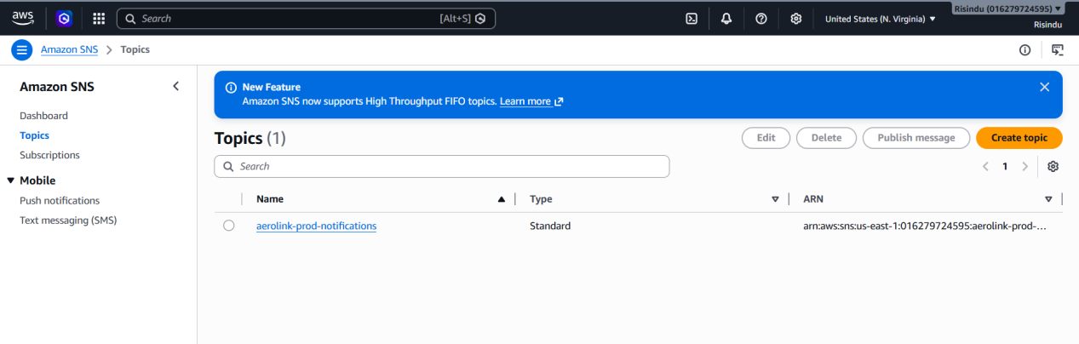
Image 26

Phase 5
Cloudfromatuion frontend
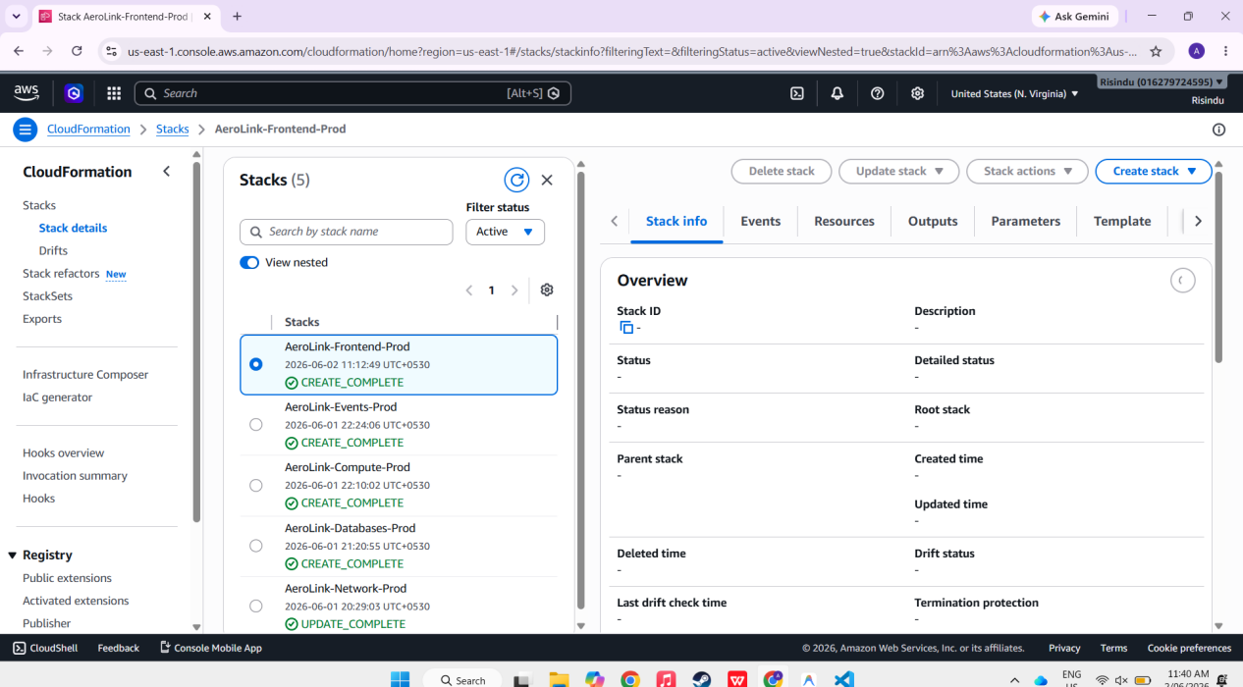
Image 27

Amazon S3 & CloudFront (Proof of Frontend Hosting & CDN)
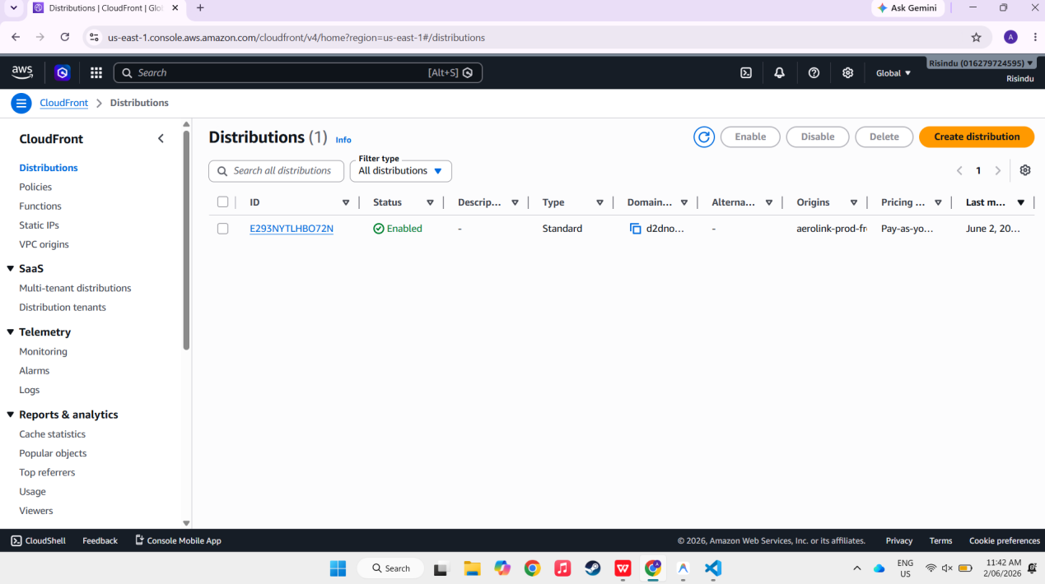
Image 28

Cloudwatch

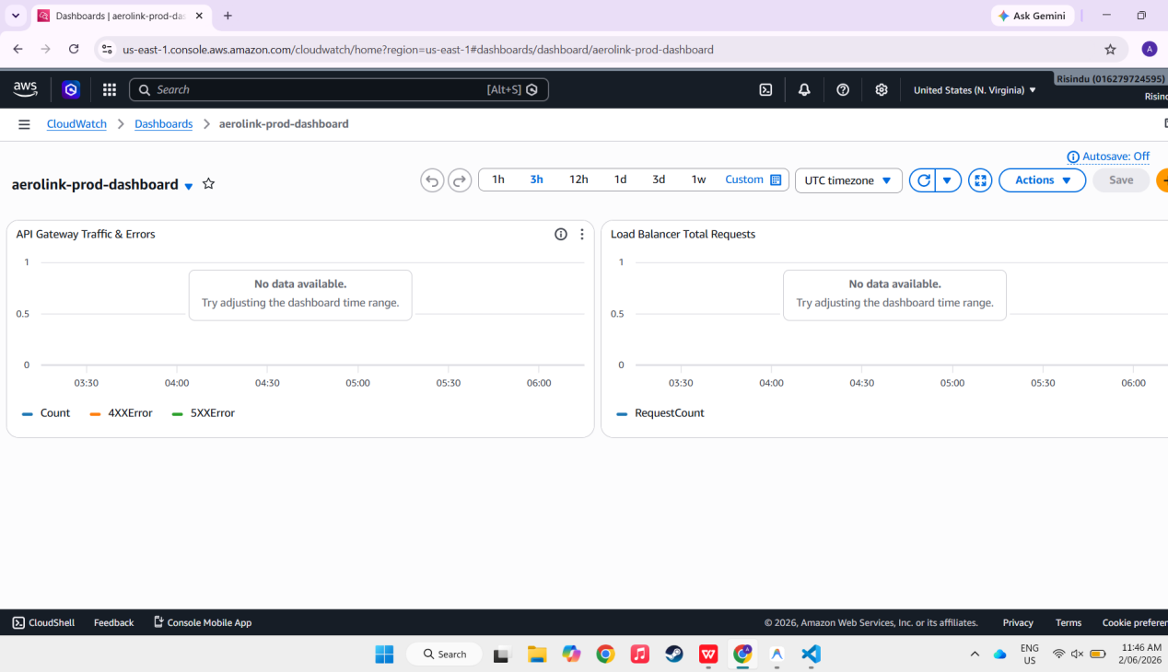
Image 29

Xray
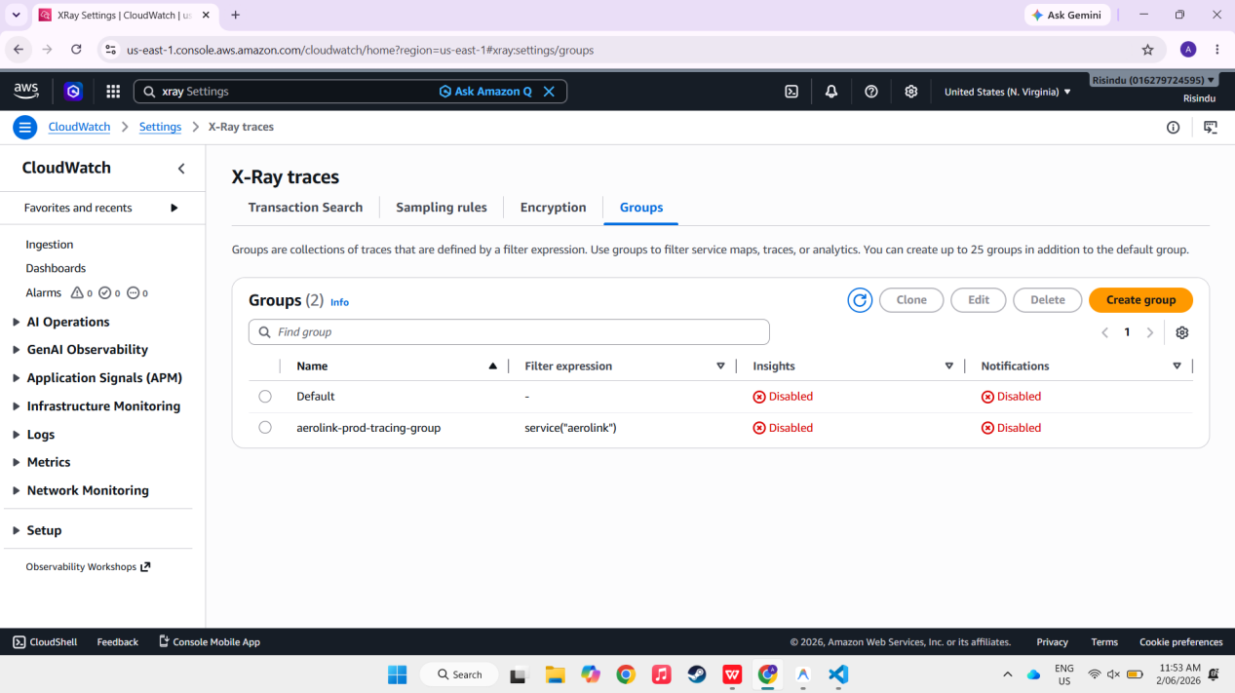

Task 5 - Cloud Deployment Preparation

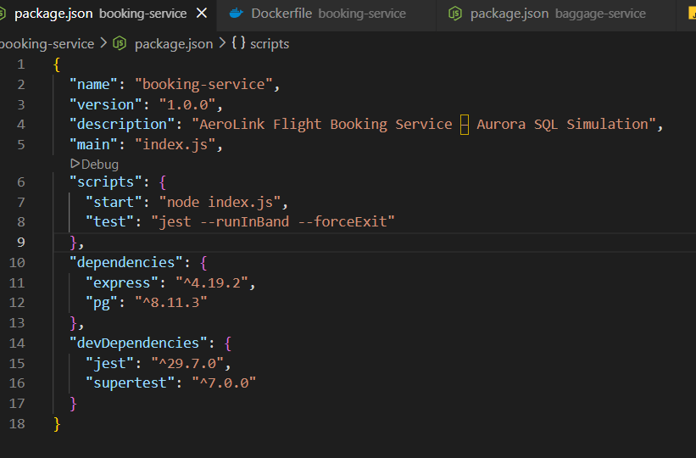
Image 30 - "Added the node-postgres (pg) driver to the Booking Service to allow it to connect to the Amazon Aurora Relational Database."

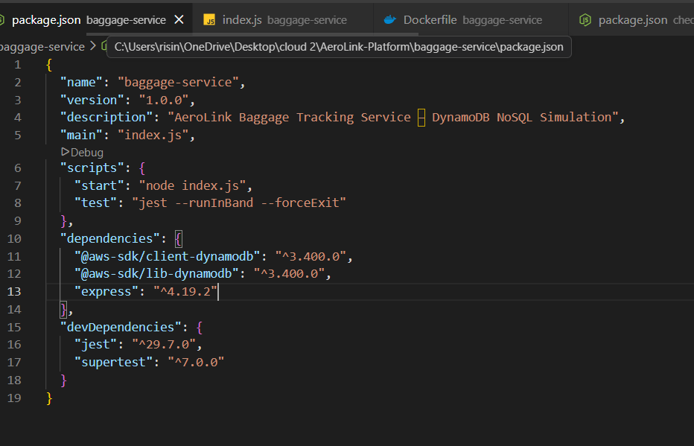
Image 31- "Installed the official AWS SDK v3 into the Baggage Service to enable real-time reads and writes directly to the Amazon DynamoDB Global Tables."

Index.js booking service
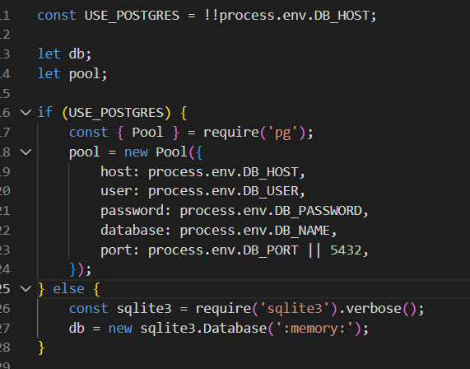
Image 32 - Implemented environment-based configuration logic in the Booking Service. This industry best practice ensures the service dynamically connects to Amazon Aurora when deployed in the AWS Cloud, but safely falls back to local SQLite for local testing and development."

Microservies for cloud migration

Booking service ecr (docker image upload)
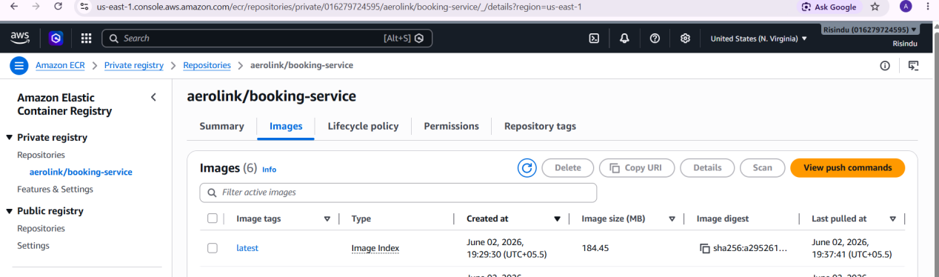
Image 33

Baggage service
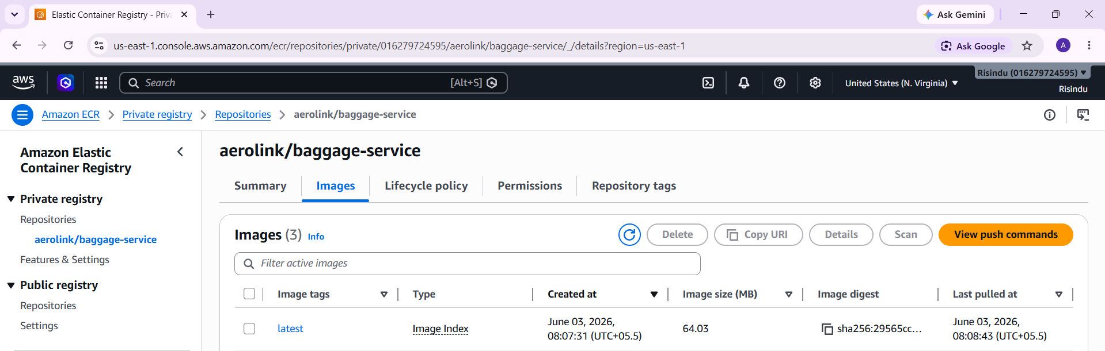
Image 34

Chekin service
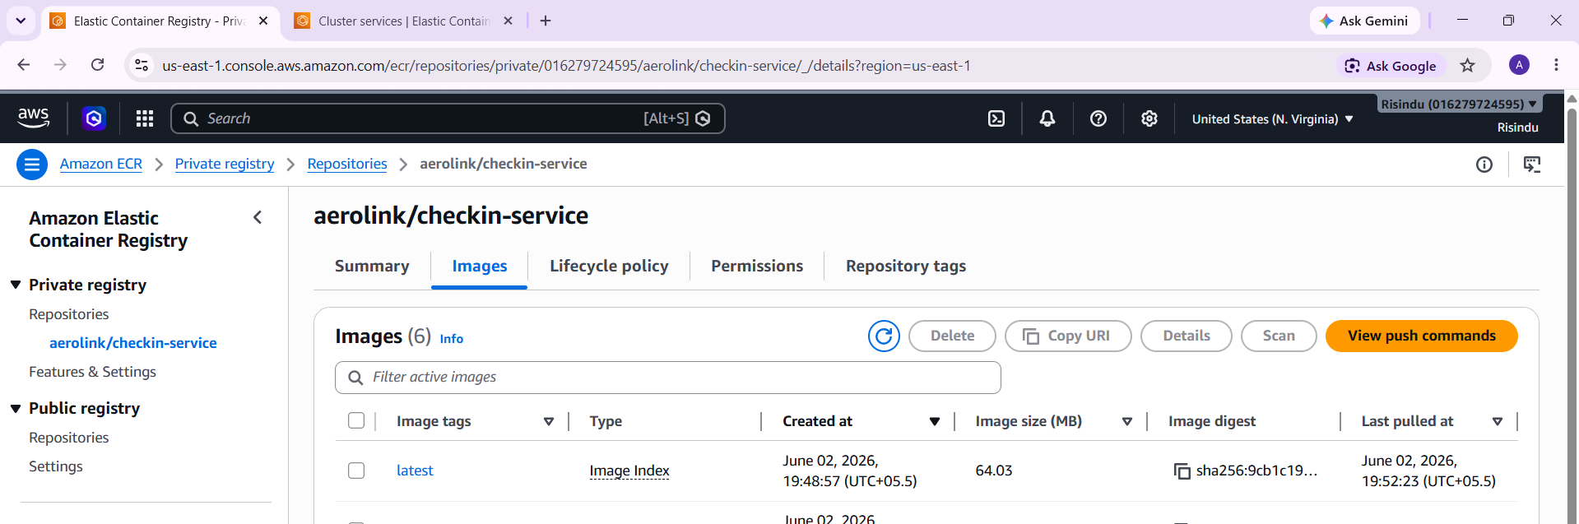
Image 35
Flight ops
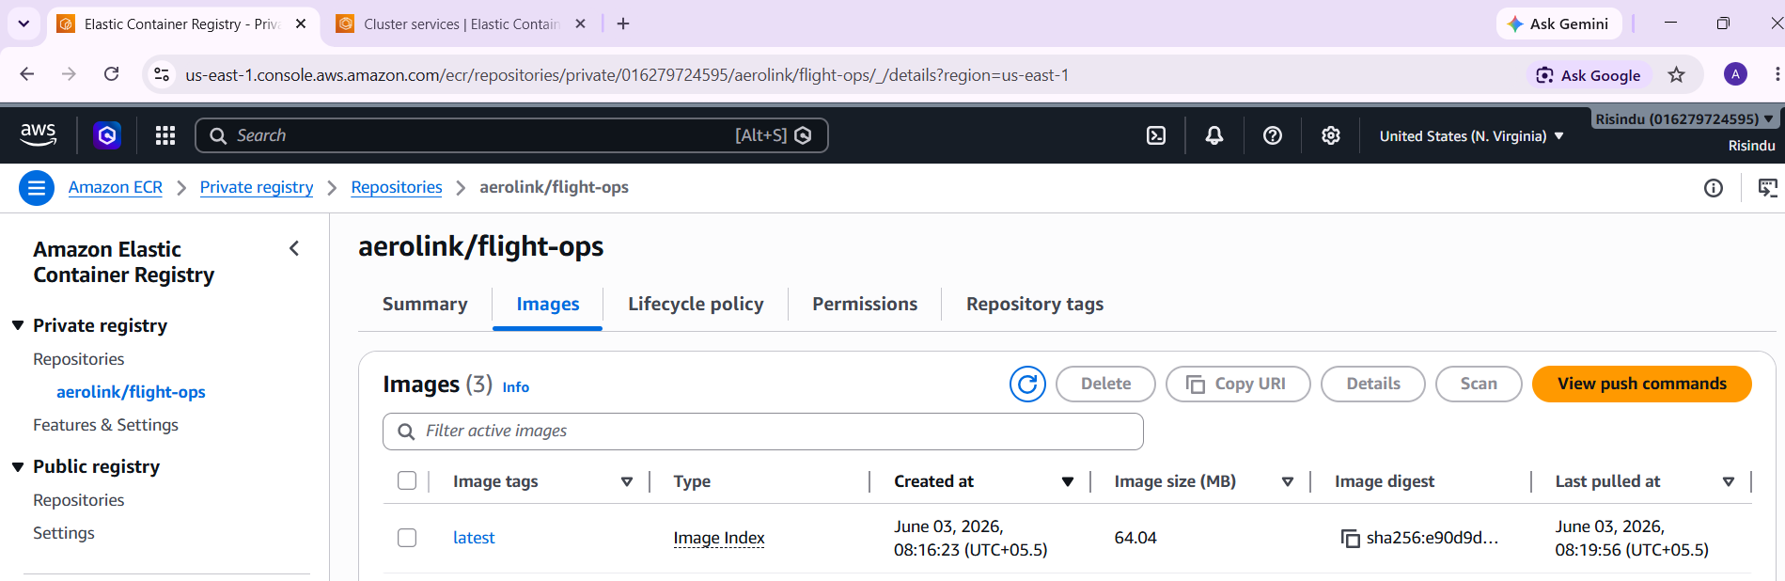
Image 36

ECS fargate running container

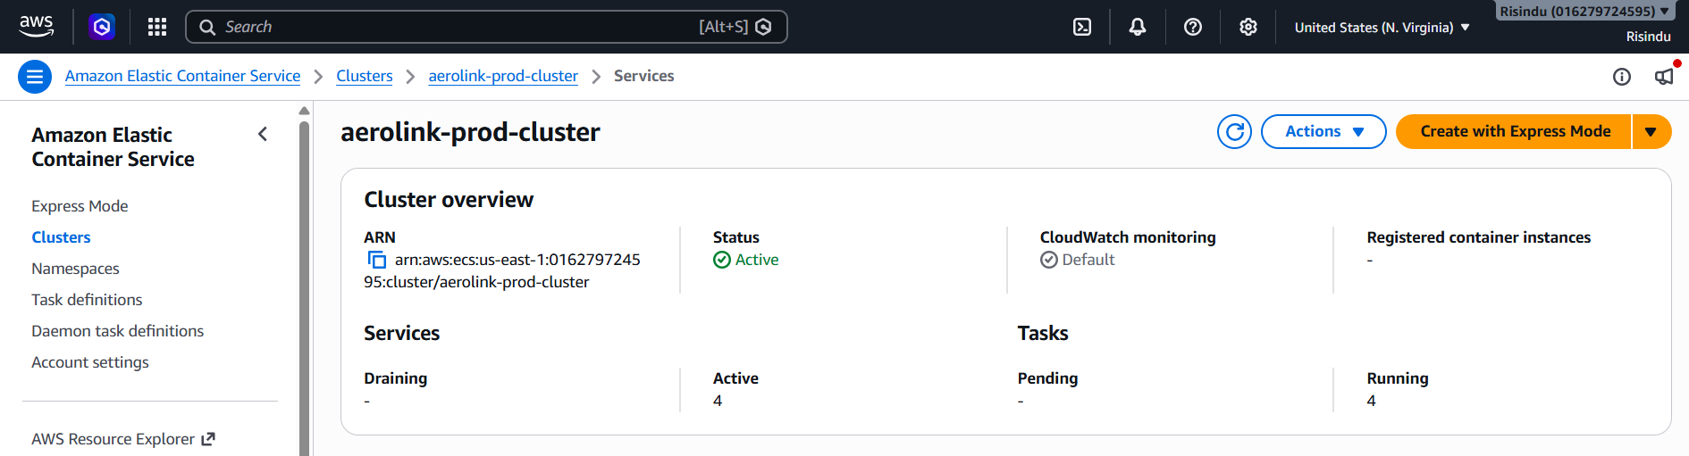
Image 37

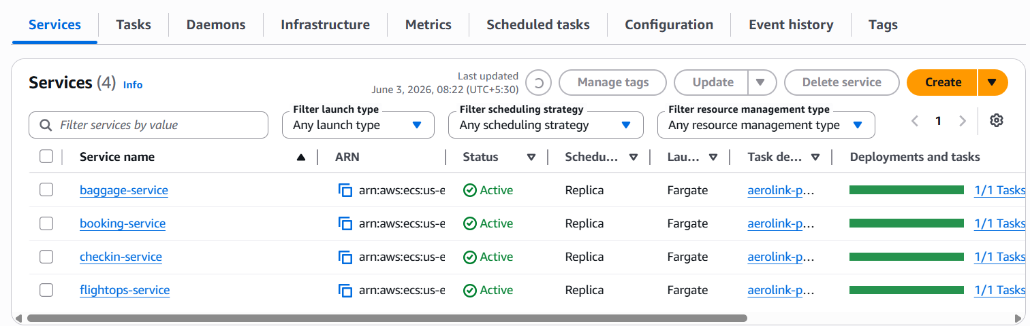
Image 38

Live site - Cloudfront url

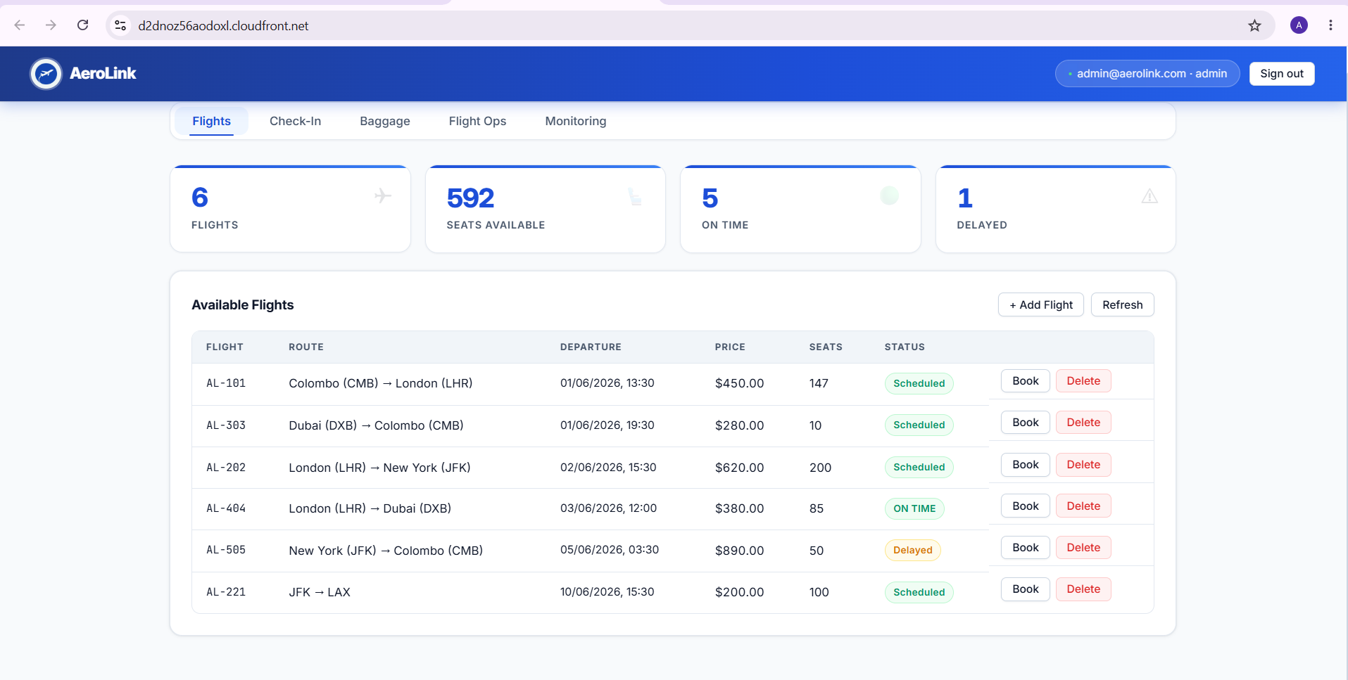
Image 39

Seat number going down after booking - database is correctly processing reservations.

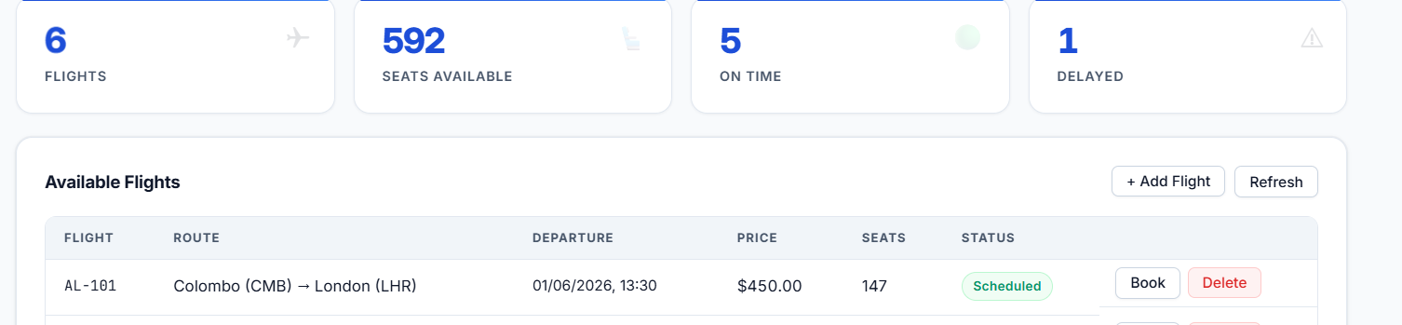
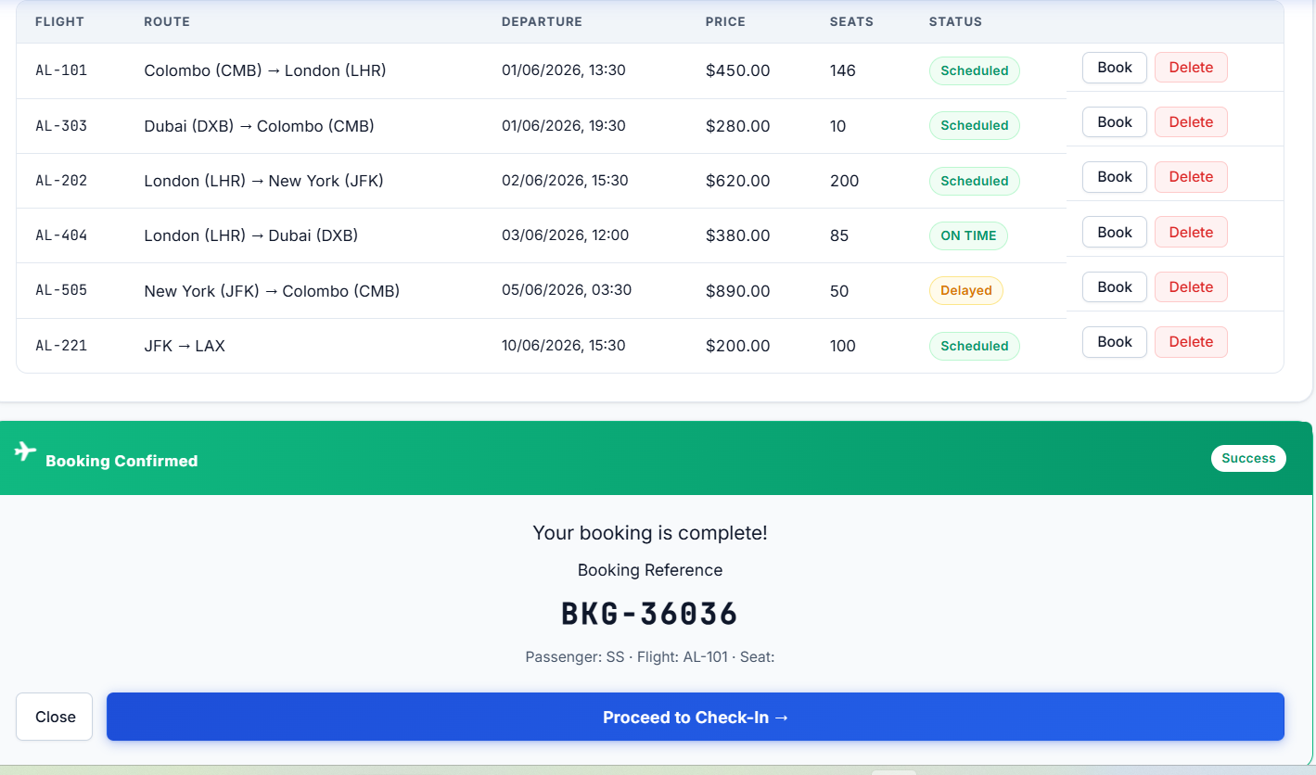
Image 40

Flightops service
This proves the complex cross-service communication (DynamoDB -> FlightOps -> ALB -> BookingService) is working flawlessly in the cloud.
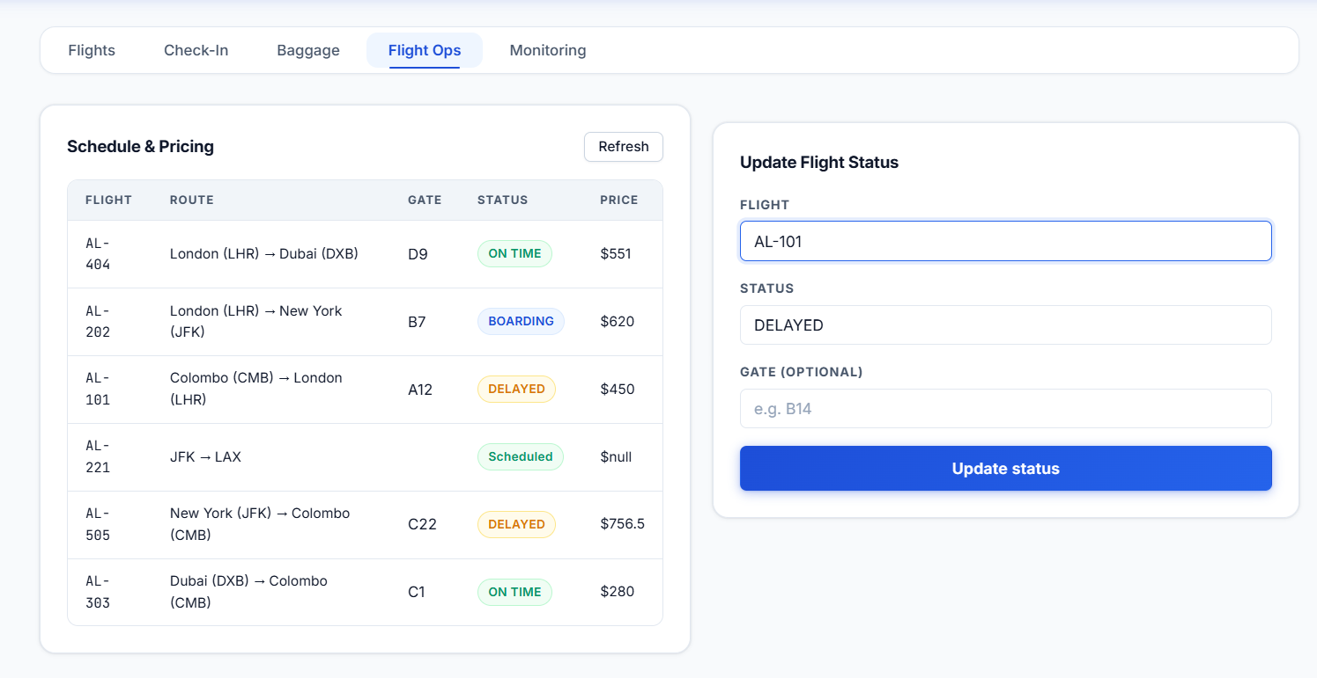
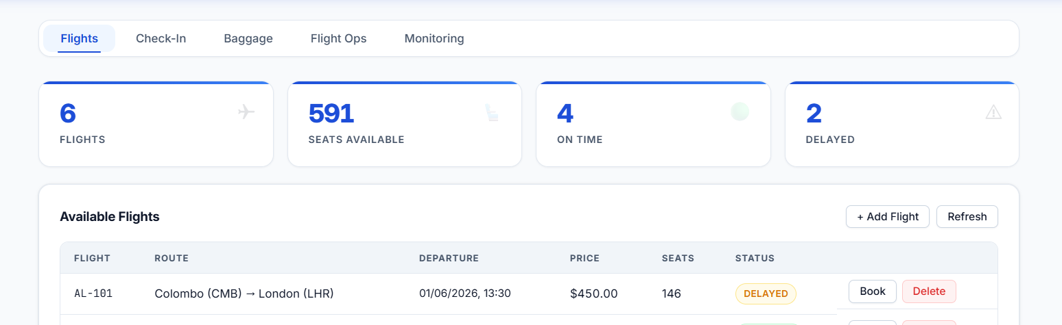
Image 41

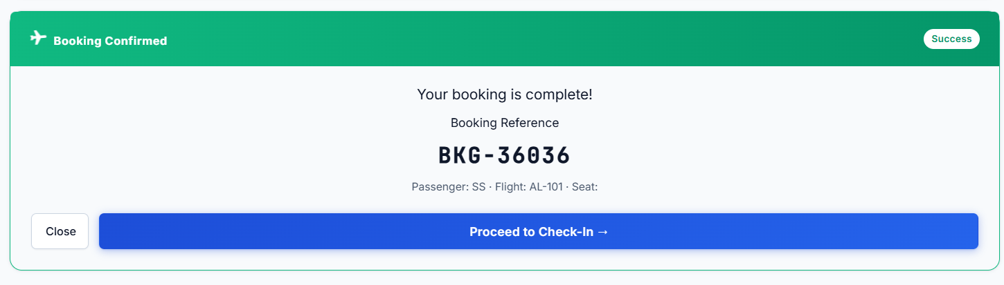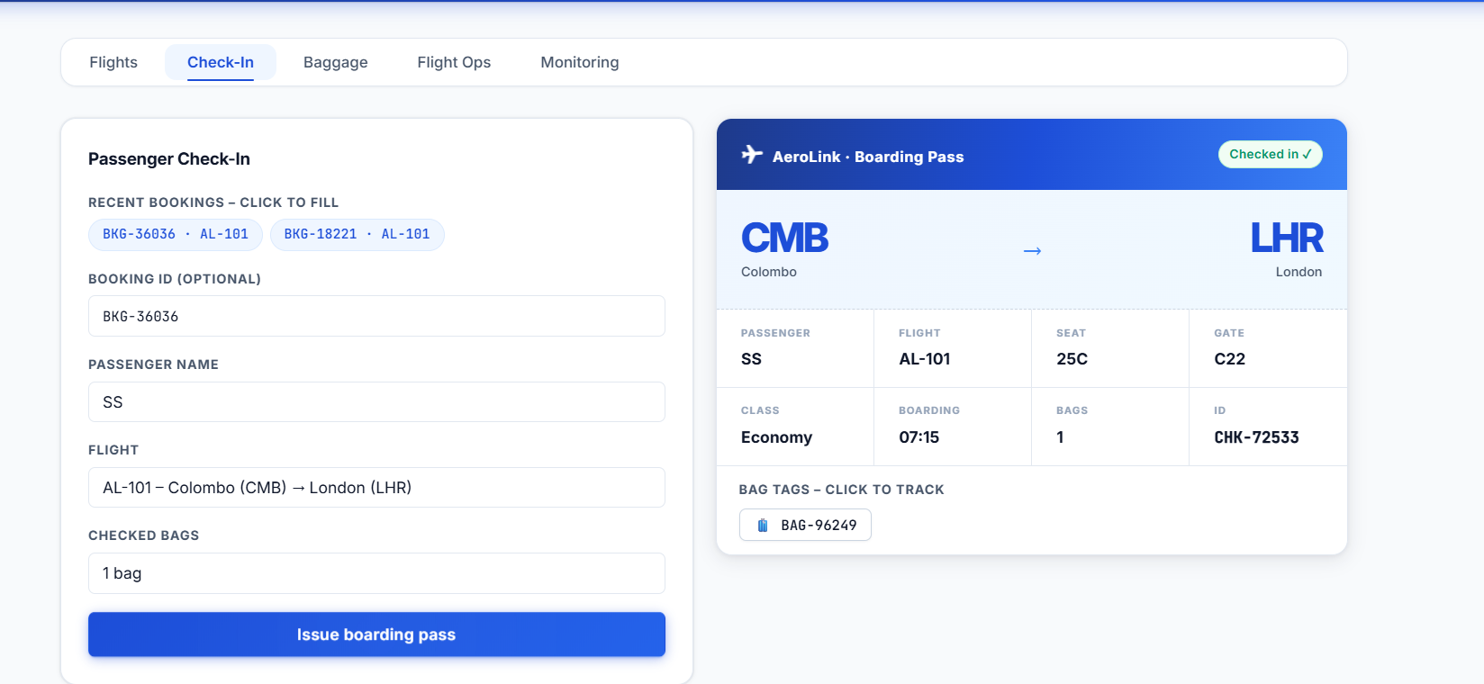
Image 42 -creenshot of the check-in success message or the boarding pass details that appear on the screen. This proves the Check-In microservice is communicating with the Booking microservice.

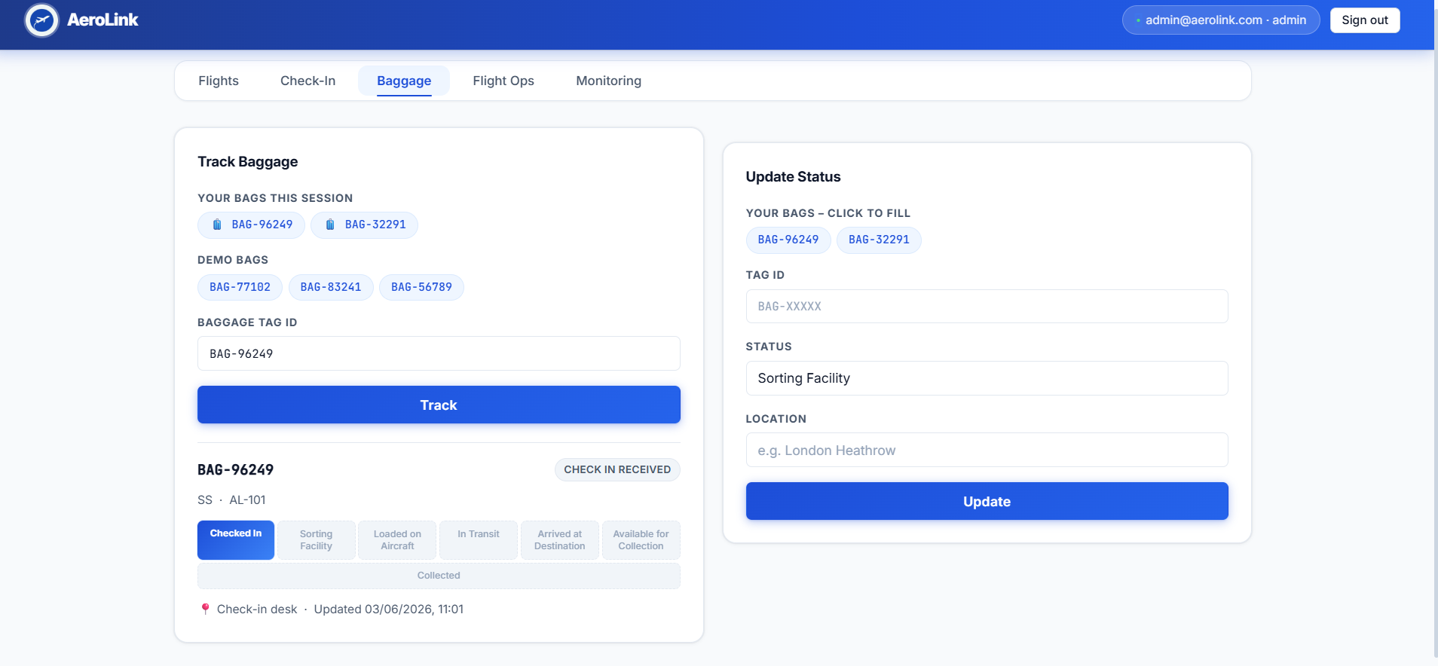

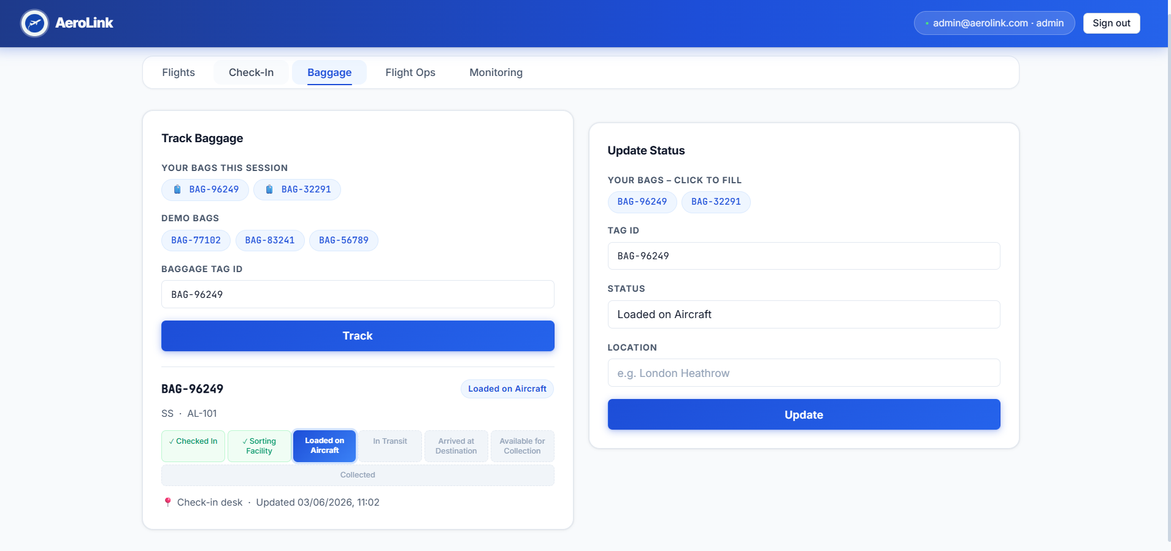
Image 43 - a screenshot of the Baggage dashboard showing the updated bag status. This proves the Baggage microservice is successfully reading and writing to its DynamoDB table.

All services running
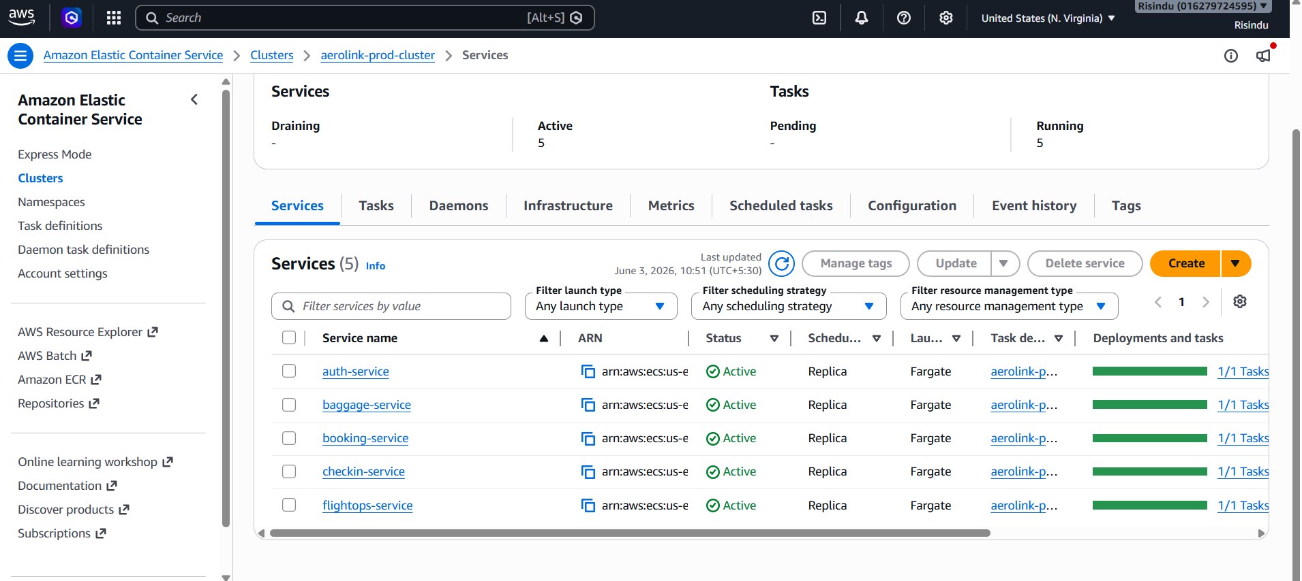

PostgreSQL (RDS)

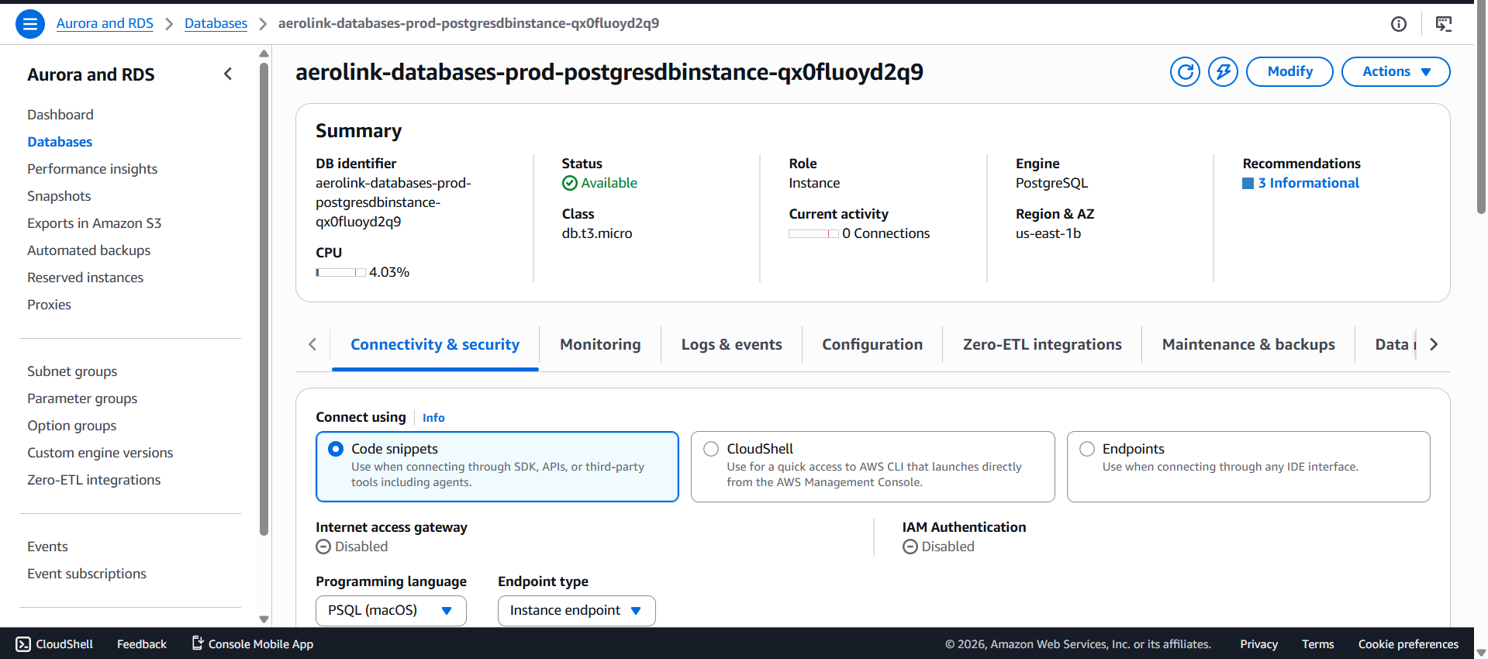

Dynamodb

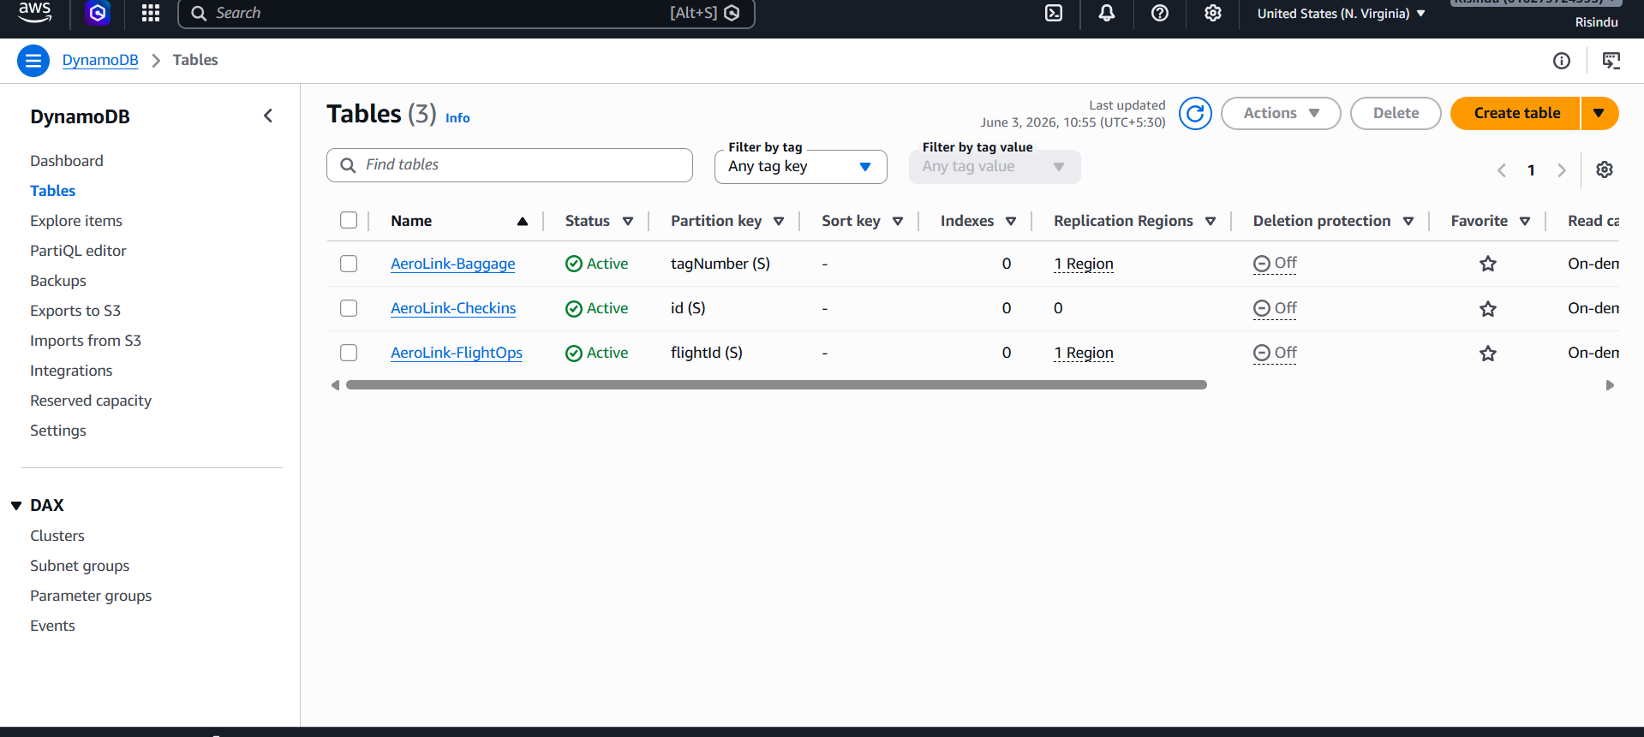

AWS lambda
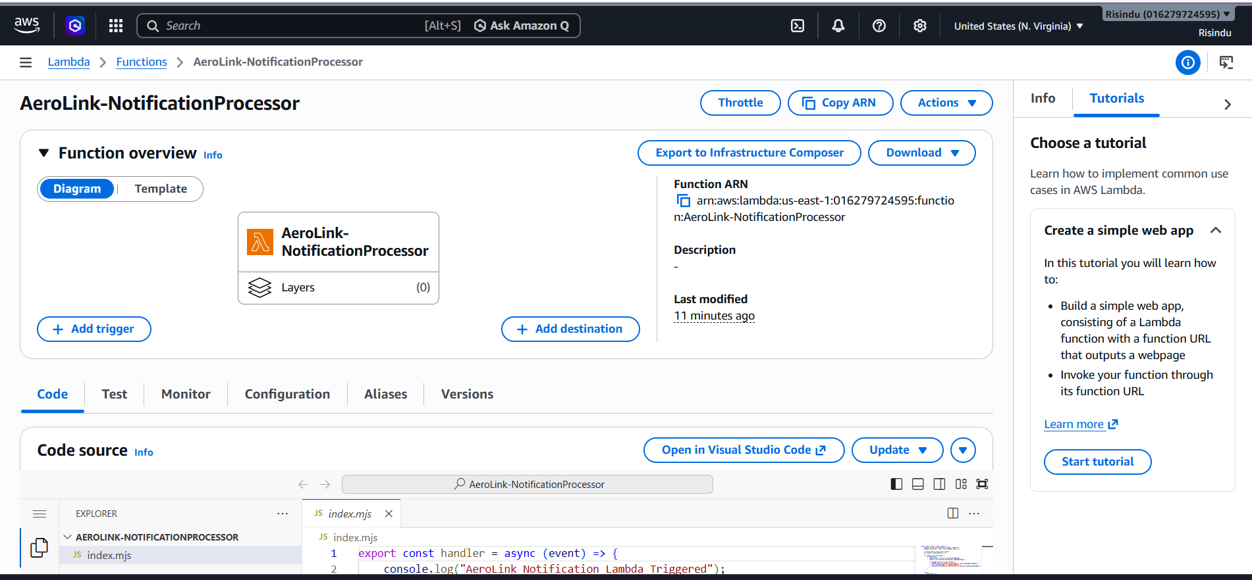
Image 44

Circuit breaker
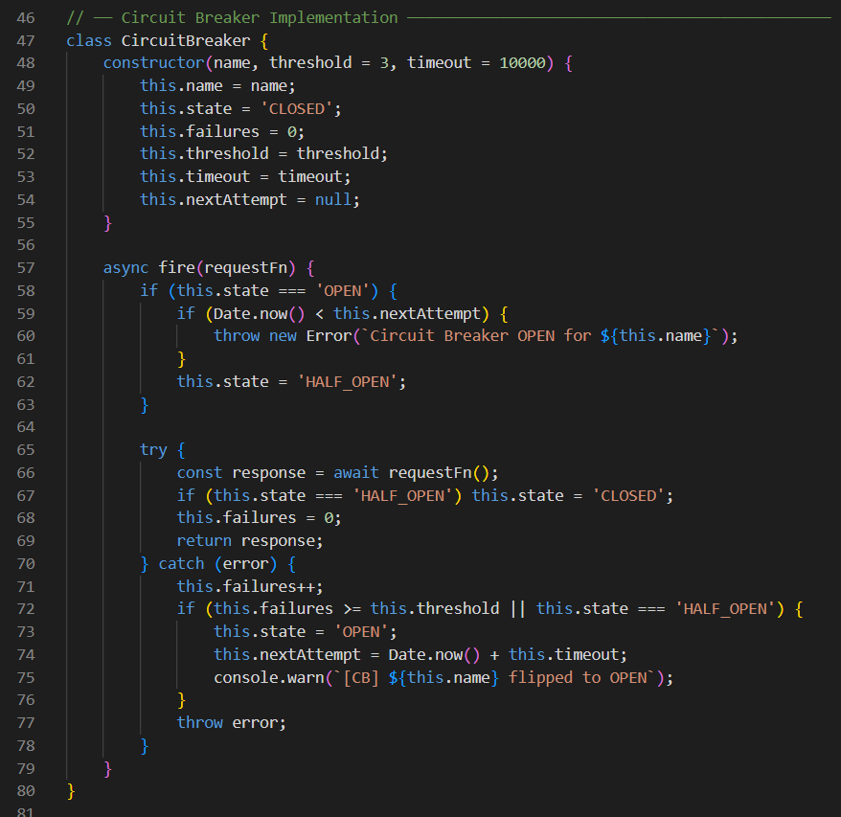
Image 45

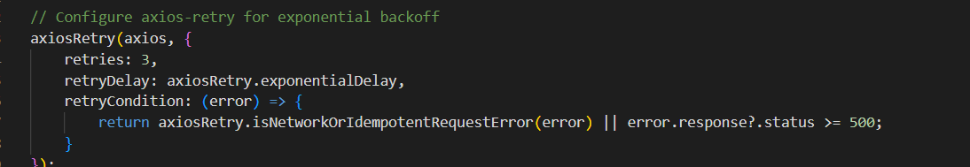
Image 46 - retry

Ecs booking service autoscalling
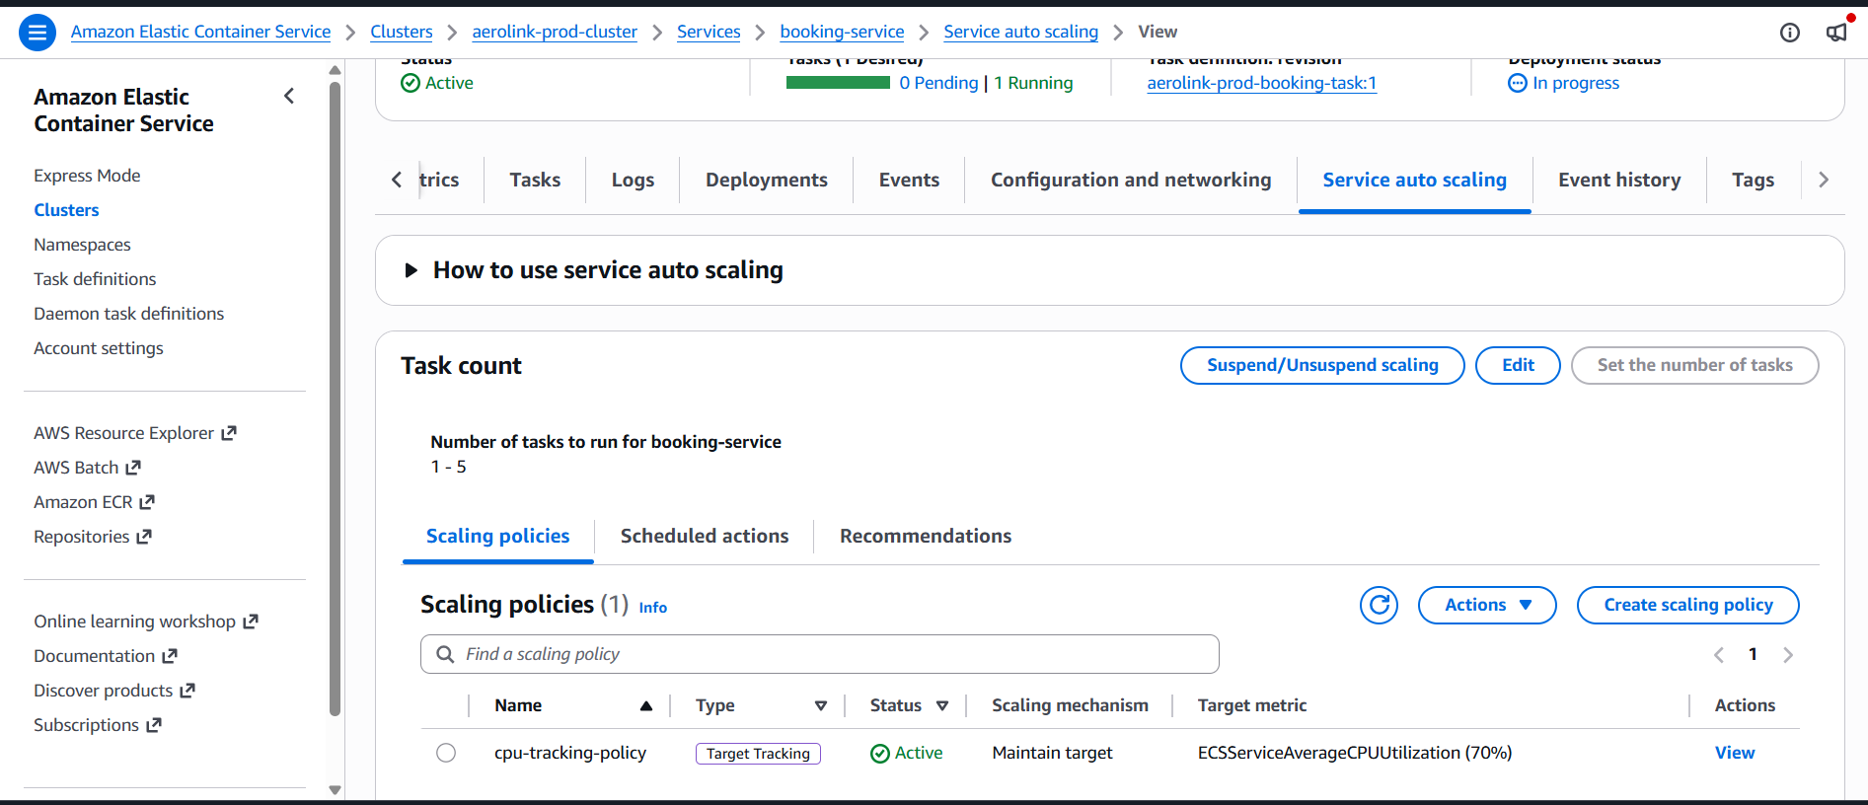
Image 47- cpu-tracking-policy configured to scale out when CPU > 70%.

Swagger api documentaion
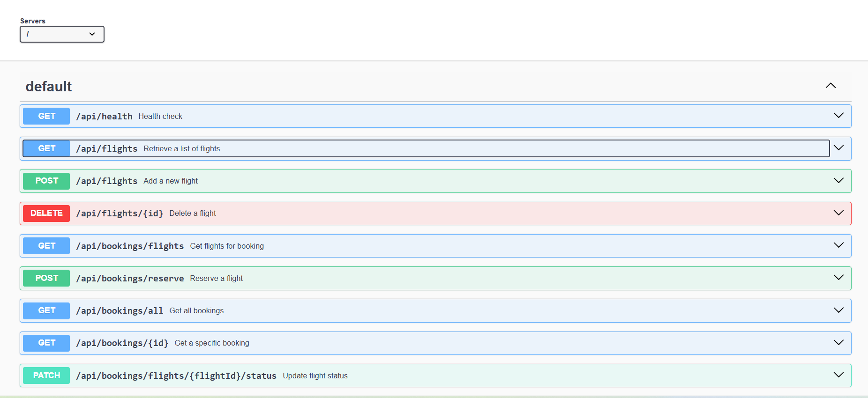
Image 48

Testing proof

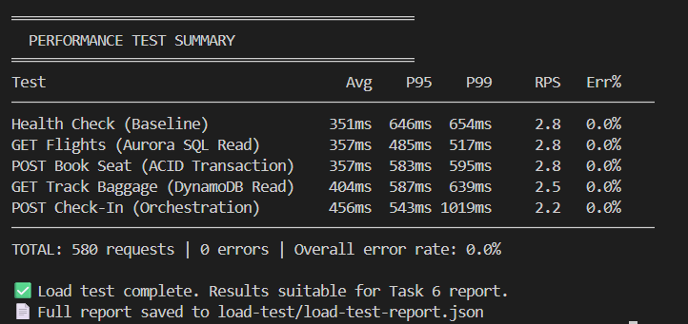
Image 49 - Performance & Scalability Testing

Monitoring and observability
Log groups
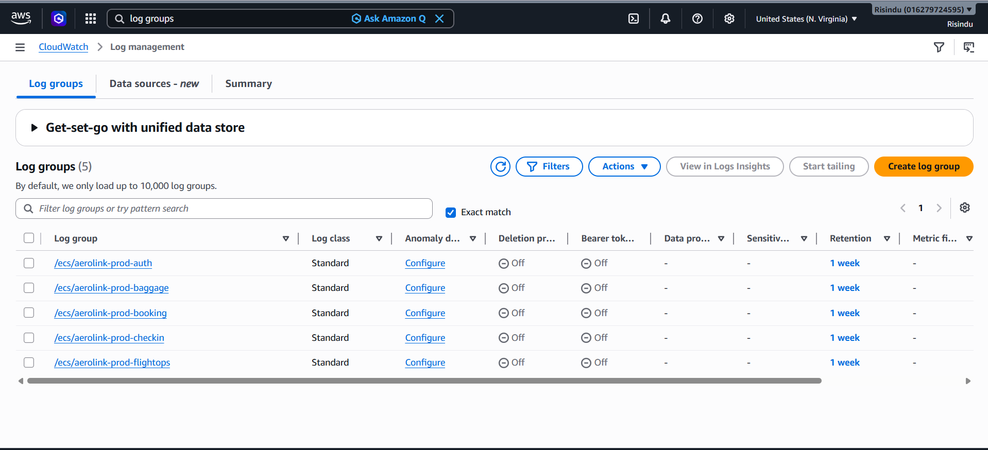
Image 50

Prod-auth log group
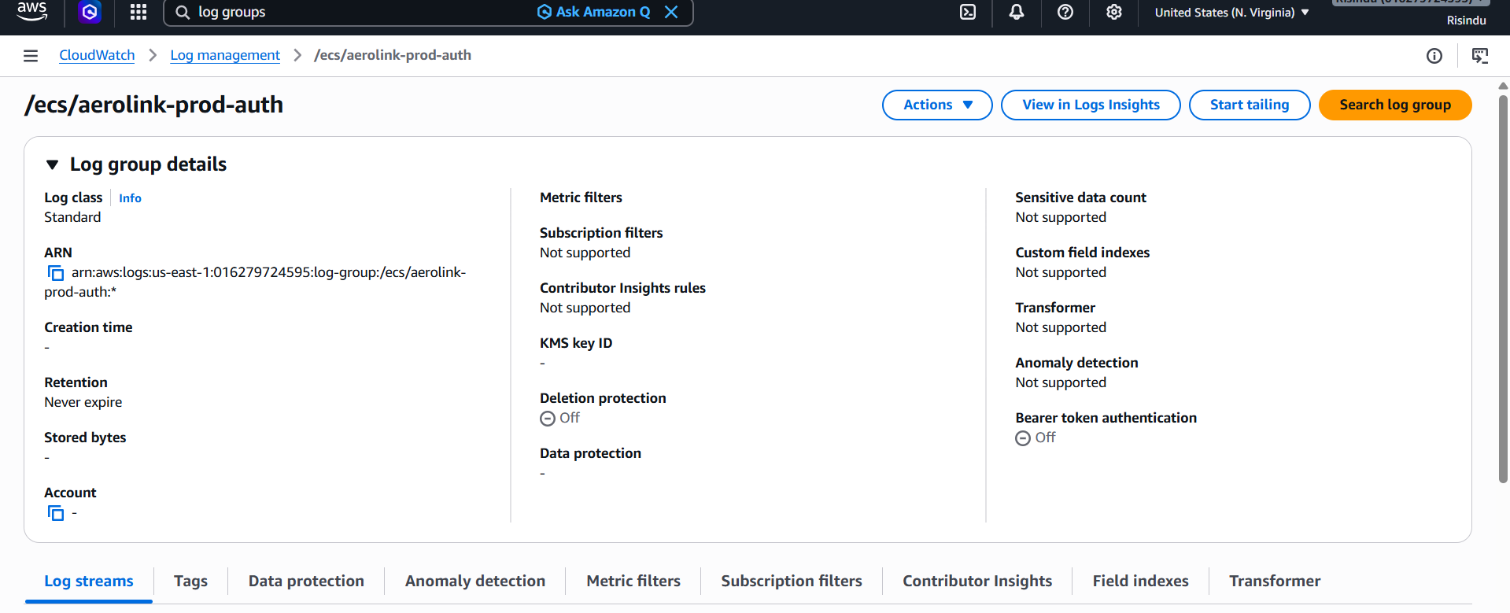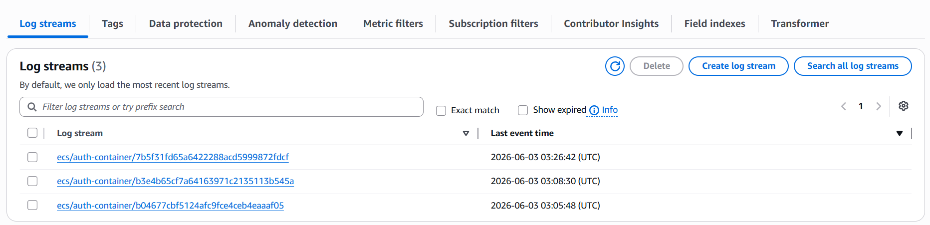
Image 51

Prod-booking log group
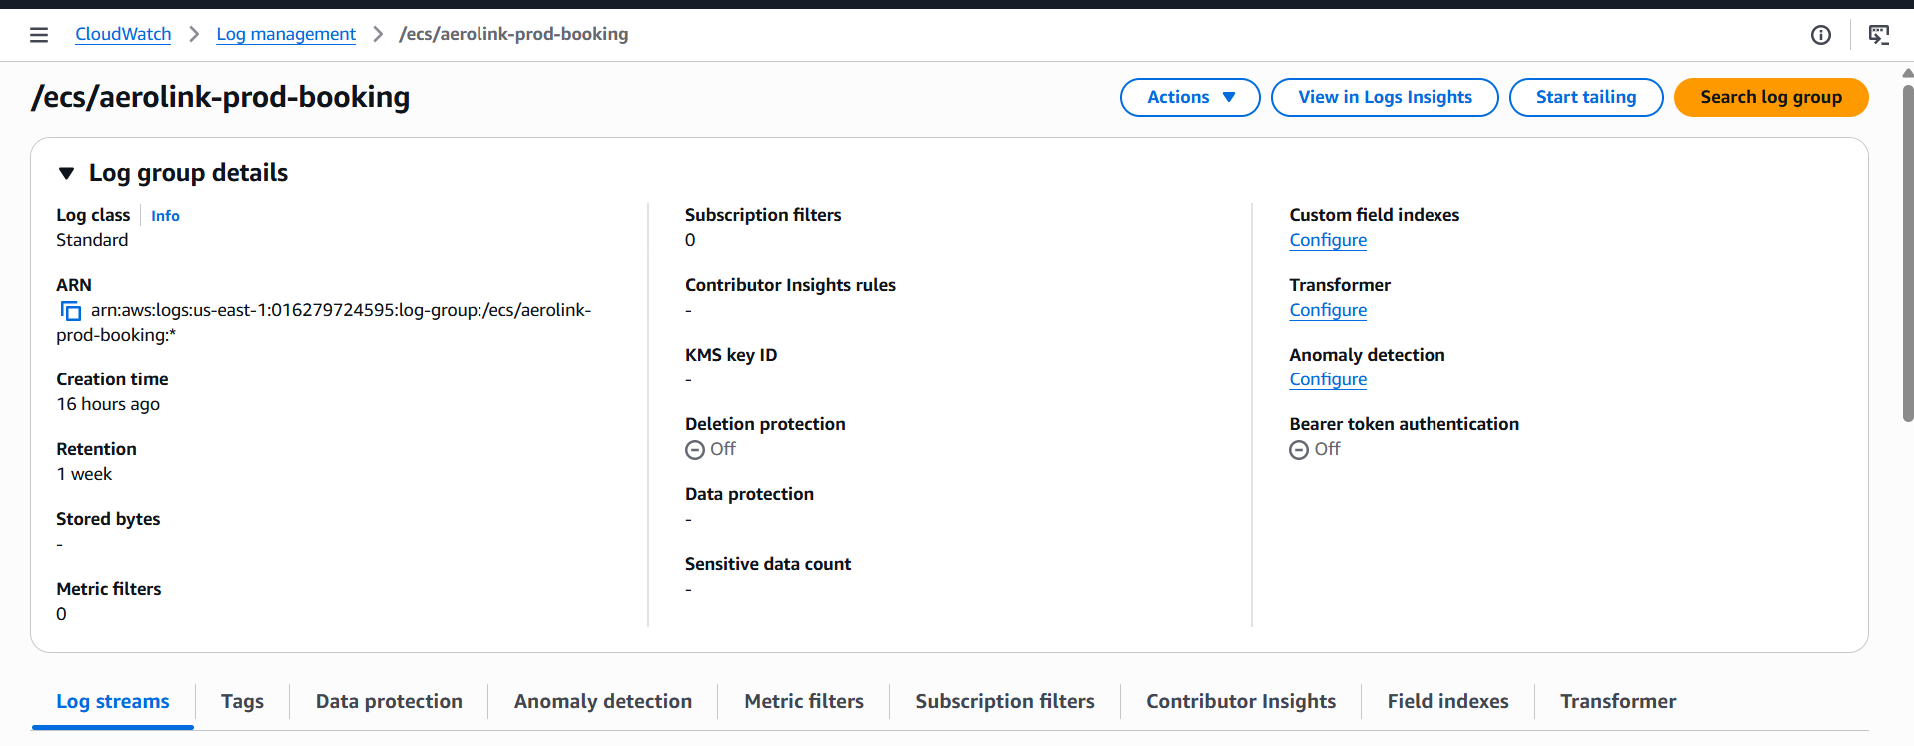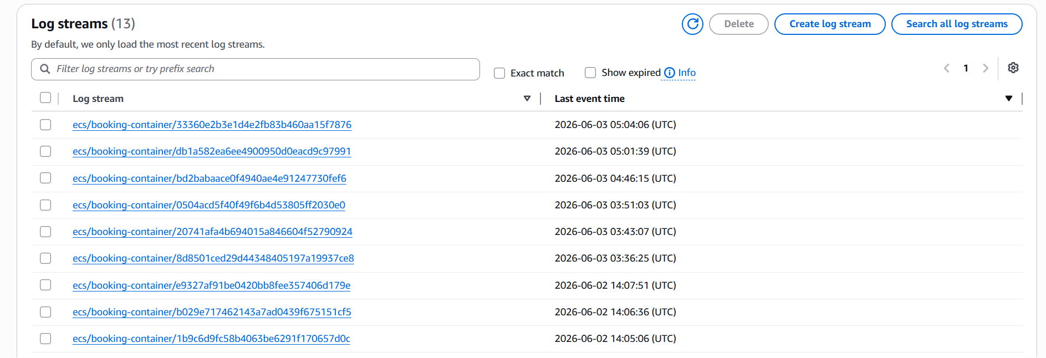
Image 52

Testing strategy

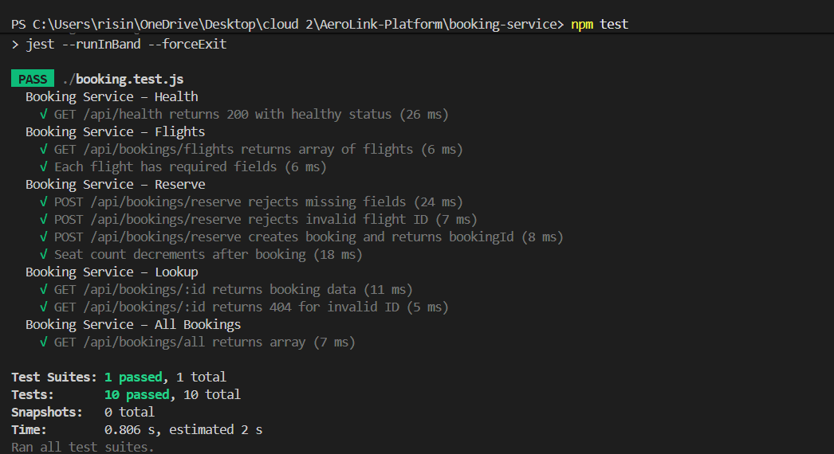
Image 53 - implemented Unit Testing for your microservices.

Stress test

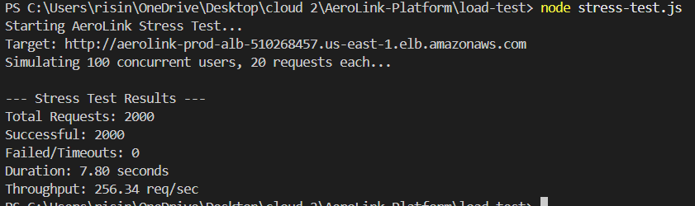
Image 54

Image 55 postman
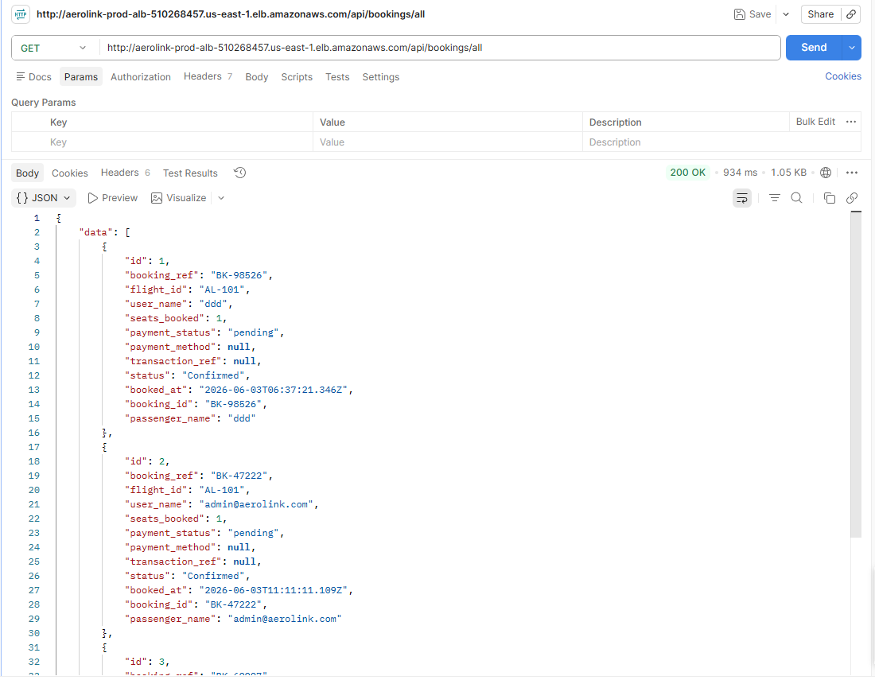

Image 56 - OAuth 2.0 / RBAC Screenshot
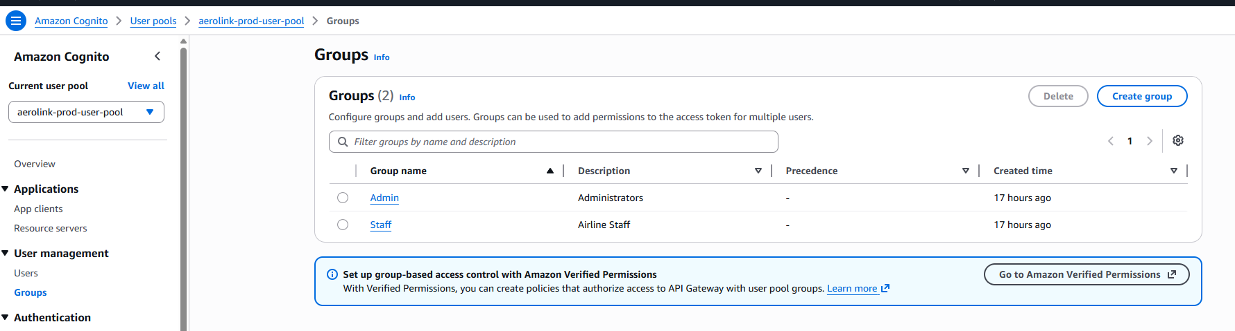

Image 57 – Disaster Recovery Strategy

